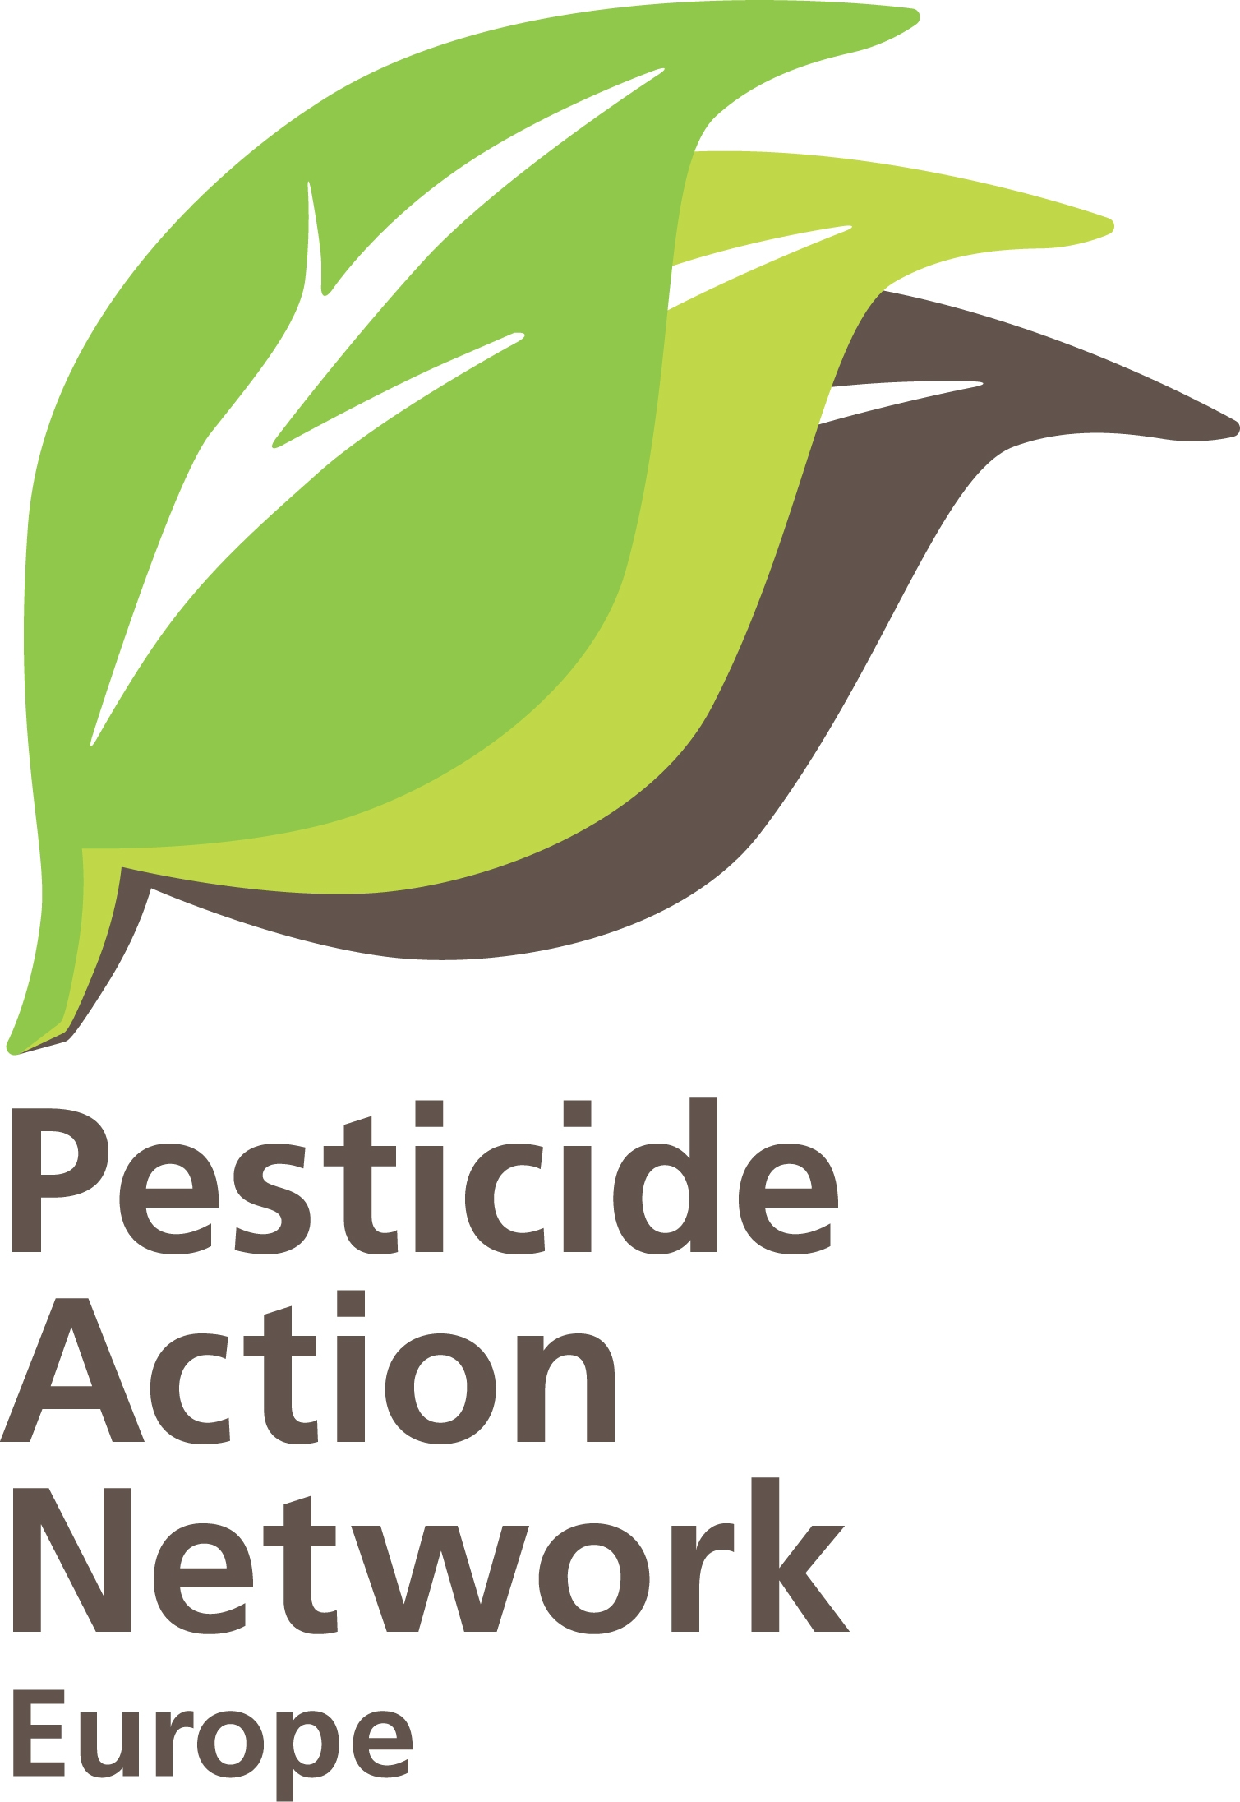 | SANTE’s report to the Ombudsman  Brussels, 17-04-2018.  Contact : Hans Muilerman  hans@pan-europe.info  tel. 0031655807255.

To: Mr. Vytenis Andriukaitis
European Commissioner for Health and Consumer Policy
European Commission
B-1049 Brussels.

Subject: Comments on DG SANTE’s report of February 14, 2018 in reply to the Ombudsman’s findings on “confirmatory information”.

Dear Commissioner Andriukaitis,

We are writing to you in relation to the report produced by your Directorate-General and sent to the Ombudsman on 14th February 2018 (“Commission Report in reply to a further remark from the European Ombudsman in her closing decision”) following PAN Europe’s complaint to the Ombudsman in 2013.

We would like to share with you the following observations regarding your report and kindly ask you for your reaction to our observations.

- Decisions on “confirmatory information” (CI).

In the report DG SANTE claims that only in a minority of the decisions taken on pesticides (approvals) was the CI procedure requested, in 24 out of 65 decisions (37%), according to page 7 of the report. In our sample of 2014/2015-decisions submitted to the Ombudsman CI was requested in 22 out of 24 decisions (88%), and in our mid-term review on 2016-decisions submitted to the Ombudsman it was requested in 11 out of 14 cases (79%). We question therefore your unsubstantiated claim and ask for an explanation. Also, the number of 65 decisions seems too low since around 193 decisions have been published based on Regulation 1107/2009. We ask you to justify the 65 decisions you mention.

In her verdict the Ombudsman stated: “The Ombudsman expects that, from now on, the Commission will use the CDP (=CI) in a more restrictive manner. Thus, she trusts that if the complainant were to repeat the exercise it carried out when examining a sample of approved substances, in a few yearsʹ time, it will note a significant decrease in the use of the CDP”. However, our mid-term review in 2016 shows clearly that DG SANTE hasn’t changed its practice and you have breached the trust given to you by the Ombudsman.

- The three types of CI that you claim to use for decisions (pages 4, 5, 6 of your DG SANTE report).

- Your first claim is that CI can be requested for the precise composition of the active substance. This claim is legally unjustified. The precise composition should be provided by the applicant in the application dossier according to the data requirements (point 1.11, Regulation 283/2013). If the applicant fails to do so, the rapport Member State (RMS) cannot decide to the completeness (Art. 3, Regulation 844/2012) and admissibility of the dossier (Art.9, Regulation 844/2012 and Art. 9.3, Reg. 1107/2009) and should postpone a decision till the dossier is complete.

- The second claim you make is that a new classification can lead to CI. This is again legally unjustified. It is the RMS that has to check FIRST (Art. 4.1) if the substance meets the 'hazard' çriteria: "The assessment of the active substance shall first establish whether the approval criteria set out in points 3.6.2 to 3.6.4 and 3.7 of Annex II are satisfied. If these criteria are satisfied the assessment shall continue to establish whether the other approval criteria set out in points 2 and 3 of Annex II are satisfied". This means at the very early stage (at least 3 years before a decision on approval is taken) the RMS shall assess if a substance is subject to 'hazard' criteria, such as a harmonised classification, and act. This should not be done at a very late stage of the pesticide evaluation carried out by EFSA (peer review). If a substance is to be classified, the information should already be available in the dossier and possibly in peer-reviewed literature. The RMS can derive this information and decide on the need of a classification for hazards, such as carcinogenicity. It is difficult to understand that you call this a “new” requirement since Art. 4.1 of Reg 1107/2009 has been a legal obligation for several years.

The applicant shall based on Art. 8.1.a, Regulation 1107/2009 include in its dossier: “information with respect to one or more representative uses on a widely grown crop in each zone of at least one plant protection product containing the active substance, demonstrating that the approval criteria provided for in Article 4 are met”, and thus also include information on the “hazard” character of the substance, and if so and if wanted, include requests for “negligible exposure” and/or Art. 4.7 derogation.

- Your third claim that new requirements can be the result of a new guidance is highly hypothetical. If new data requirements are needed, they should be put in the Regulations on data requirements (283/2013), not in guidelines. Guidelines being accepted by Commission and Standing Committee exactly during assessment of a substance is a very rare event. No single example of the third claim is presented in DG SANTE’s report Annex.
Additionally, it is very misleading to state in this chapter (page 5) that confirmatory information is a way to obtain information in a timely manner, while you (and the RMS) in fact have failed to ask for this information at the proper time, at the stage of the completeness check and concluded to admissibility (Art. 9.3, Reg. 1107).
The information should had been requested at the time of the "completeness check" (or as a condition for the completeness check or admissibility decision), generally at least 3 years before the decision on approval is taken, leaving enough time to get information (generate data) before the approval decision and thus avoid a confirmatory information provision, avoid unnecessary delay and avoid putting humans and the environment at risk. Also the massive delays of decisions you promote (“prolongations”), a common practise in your policy of the last few years, provides enough time, from 3-4 years up to 5 to 8 years in most cases, to carry out the evaluation and for the applicant to generate additional studies where necessary.

The statement at the beginning of page 6 of the DG SANTE report that CI is not requested in case data requirements exists is misleading. In the cases presented by you in Annex I we can easily identify a range of CI requests where data requirements exists, such as: point 1.11 of Regulation 283/2013 with requirements for the technical specification of the substance (examples in your Annex I are: Terpenoid blend, Halauxifen-methyl, Flupyradifurone, Mandestrobin, etc.), point 8.3.1 of Regulation 283/2013 with requirements for bee brood, nectar, pollen (example Sulfoxaflor), point 1.11.b, 5.8.2.e of Reg. 283/2013 with testing requirements for metabolites (examples are Iprovailicarb, Thifensulfuron-methyl, Iodosulfuron, Mesotrion, Metsulfuron-methyl, L-cyhalothrin). Note that these substances are on the market for many years, sometimes decades, raising the question why this information is not asked in an earlier stage instead of after an approval.

And, in all of these cases there is nothing to “confirm”. EFSA, generally, has demonstrated a data gap or -worse- a “critical area of concern”, and no safe use has been demonstrated and there is no possibility of approving the substance from a scientific point of view. This is the case for genotoxic metabolites, for endocrine disruptors, drinking water pollutants, etc. EFSA indicates risks and presents no evidence for safety. It looks like for DG SANTE the risk for human health and the environment is inexistent until the contrary is proven. It is a reversal of the burden of proof which should be on the shoulder of the industry to demonstrate that its product is safe.

Further is it unacceptable to keep on applying this misleading language whereby you “confirm” safety while EFSA has precisely demonstrated non-safety. You put the precautionary principle upside-down and put people and the environment at risk. Potential genotoxic metabolites and potential pollutants of drinking water are approved for use, with potential serious and irreparable effects.

In conclusion, DG SANTE fails to show that “the confirmatory data procedure is used restrictively, and strictly in line with the applicable legislation”. It is not restrictive. Even in 2016 (PAN mid term review) the CI derogation was used in 11 out of 14 decisions taken (79%). And -even worse- in none of the cases (as well as in the cases mentioned in your Annex I) was the legal provision respected (Art, 6f; Reg. 1107). In no single case was CI used as a result of new scientific insights. This is perhaps to be expected since new scientific insights are rarely taken into account (see research outcome of the Pesticide Action Network, Missed & Dismissed ) and academic literature is habitually dismissed.
Furthermore, the criteria for the second partof Art. 6.f, new requirements established during the evaluation, were not met either. In few cases, new requirements were indeed identified (bees, endocrine disruption), but these were requirements that DG SANTE had failed to include in data requirements at an earlier stage, and therefore these requirements were not established DURING the evaluation as you claim (in fact this just demonstrates a failure to fulfil the obligation to update the data requirements with new testing protocols).

- EFSA peer reviews on “confirmatory information”.
In your report you state: “the Commission has considered whether all confirmatory data should systematically be subject to an EFSA peer review (and whether the ad hoc Guidance document concerning the evaluation of confirmatory data should be amended accordingly). In the event that the Commission decides that EFSA peer reviews concerning confirmatory data need not be systematic, the report should give reasons for that position”. The short conclusion on this chapter is: no, in reality you did not consider whether the assessment is systematically made subject to an EFSA peer review. Much was written in your February 2018-report on the “reporting table”, where Member States and EFSA can comment on the conclusions of the RMS, but this has nothing to do with an EFSA peer review. Commenting is also not a ‘fast-track’ peer review as was misleadingly implied. SANTE did not mandate EFSA to do a peer review; not a single case is mentioned. SANTE apparently also did not even consider to do it, but simply continued its standard practice of ‘reporting tables’. One may assume that there is a misconception of what a peer-review is.

- Mitigation measures included in the approval decision.
The Ombudsman requested that DG SANTE was to “show that the Commission has reviewed its approach to the definition of mitigation measures and that its approval decisions include further requirements which reflect EFSAʹs conclusions”. However, in its report, DG SANTE simply keeps on repeating earlier positions on subsidiarity and such, and there is no evidence that a review has taken place.

While a review remains to be seen, we observe, once again, that the ‘same old’ unfounded arguments are put forward by your DG:

- Claiming that MS have to set mitigations measures is correct, but without mitigation measures in the approval decision, a safe representative use cannot be usually demonstrated in the approval decision.
- Claiming, in relation to buffer zones (page 11), that mitigation measures are not possible because this will prevent flexibility and innovation at national level, is misleading. The topic of ‘no-spray’ buffer zones has been discussed for decades, spray nozzles have been on the market for years and studies on their effectiveness have been conducted in many Member States. In fact, the establishment of buffer zones is no real innovation. EFSA could and should define the risk mitigation measures. If needed, EFSA could present a choice (larger buffer zone, more restrictions on nozzles and vice versa). With these approvals, the Commission is promoting the situation where far less efficient mitigation measures are practiced, if any at all. This is in fact the usual practice as demonstrated in the FVO-reports (page 17, verdict Ombudsman 2016). Further, as DG SANTE hasn’t enforced mitigation measures, you have lowered the level of protection required by EU Law, by permiting the Member States not to respect buffer zones. And in the end human health and the environment do not get the protection they are entitled to. The near total collapse of biodiversity (birds, bees, butterflies, amphibians, insects, etc.) in agricultural areas is clear evidence of a failing system.
- Claiming that mitigation measures should not be defined by EFSA since they ‘only’ assess one or few representative uses, in contrast to the numerous products and uses, makes no sense. For the representative uses (approval) EFSA NEEDS to define exactly the risks and mitigation measures to conclude on safety, and therefore has to be in the position (and is obliged) to define them properly. Member States can use the EFSA mitigation measures as a standard for the level of protection in additional crops applied for by industry at national level.

Finally, the ‘solutions’ often proposed by your DG in decisions, that “Member States shall pay particularly attention to …/... Conditions of use shall include risk mitigation measures, where appropriate” demonstrates the lack of commitment from your behalf to protect the environment and health and natural resources. Such clauses have no legal power and the impact is close to zero. The Ombudsman already called them open-ended and expressed her doubts if they can be legally described as requiring mitigation measure at all.

In conclusion, your Directorate General has failed to meet its obligation to review its policy on including mitigation measures in the approval decisions and just repeated its old position. The proposal of the Ombudsman that “The Commission should review its approach to the definition of mitigation measures (conditions, restrictions) and include further requirements, which reflect EFSAʹs conclusions, in its approval decisions” is disregarded by DG SANTE. Even the statement of the Ombudsman “that, in some cases, it may be useful to define certain minimum mitigation measures at EU level in a legally binding document” was not considered by your DG.

Your promise in response to the Ombudsmans’ proposal that “the Commission agrees that it will review its approach to the definition of mitigation measures and will include further requirements” has therefore been broken.

- FVO (now HFAA, Health and Food Audits and Analysis) audits of national authorisations.
Your FVO-reports show that the national authorisations are “significantly delayed” (not implemented properly), and that in the Member States 9-33% of the national authorisations the EU approval decision are not implemented. The proposal of the Ombudsman to systematically verify mitigation measures at national level is in your report referred to a future report of your so-called REFIT programme. The REFIT programme, however, is mainly focussed on deregulation and reducing costs for industry, so this reference is not in the public interest and we ask you to follow the proposal of the Ombudsman strictly.

Given the numerous academic reports on bird decline, bee decline and insect population collapse, all signs indicate that Reg. 1107/2009 is not functioning properly. The question is why you do not act knowing that provisions are not properly implemented at national level in many cases and the environment not protected sufficiently. You mention dialogue and correspondence with Member States but this is apparently not very effective. You don’t mention enforcement of the EU decisions, a tool that will likely be much more effective. We ask you to start thinking about enforcing mitigation measures and start infringement procedures.

- Review reports and approval decisions.
In our complaint to the Ombudsman we have critisized the false and misleading statements in DG SANTE’s Review Report and approval decisions that the use of a pesticide is safe even if EFSA didn’t demonstrate safe use (“critical area of concern”). In her verdict in 2016, the Ombudsman stated “that she could understand the complainantʹs impression that the Commissionʹs review reports and approval decisions are ʺmisleadingʺ and inaccurate”. Despite this verdict, we note that your DG keeps on writing these unfounded Review Reports and approval texts up to this day. In our mid-term review, for instance, we showed that EFSA concluded that the substances Ethofumesate, Picolinafen, Thiabendazole and Oxyfluorfen each had “critical areas of concern” (no safe use), and still your DG claimed safe use and proposed an approval. This is and remains a grave violation of Art.4 of Regulation 1107/2009. We urge you to respect scientific conclusions published by EFSA and stop writing unsubstantiated and ultimately misleading Review Reports and approval decisions.

In conclusion DG SANTE didn’t implement any of the solutions of the Ombudsman, as based on its own report,

- there is no significant decrease in the number of approved substances with confirmatory information as requested by the Ombudsman;
- the confirmatory information procedure is not used restrictively and is not in line with the Regulation (Art. 6.f, Reg 1107);
- DG SANTE did not consider whether confirmatory data should be systematically subject to an EFSA peer review;
- DG SANTE did not review its approach to the definition of mitigation measures or whether its approval decisions include further requirements which reflect EFSAʹs conclusions;
- DG SANTE refused the proposal of the Ombudsman to systematically verify mitigation measures at national level;
- DG SANTE continued producing ‘Review Reports’ and approval decisions that were classified by the Ombudsman as “misleading and inaccurate”.

We are looking forward to your reply on each of these 6 points.

Sincerely yours,

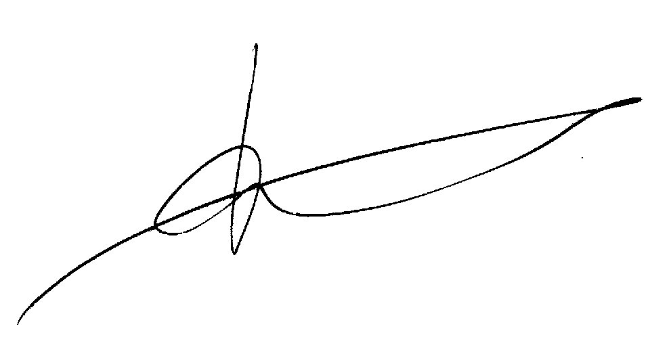

Hans Muilerman,
Pesticide Action Network.

