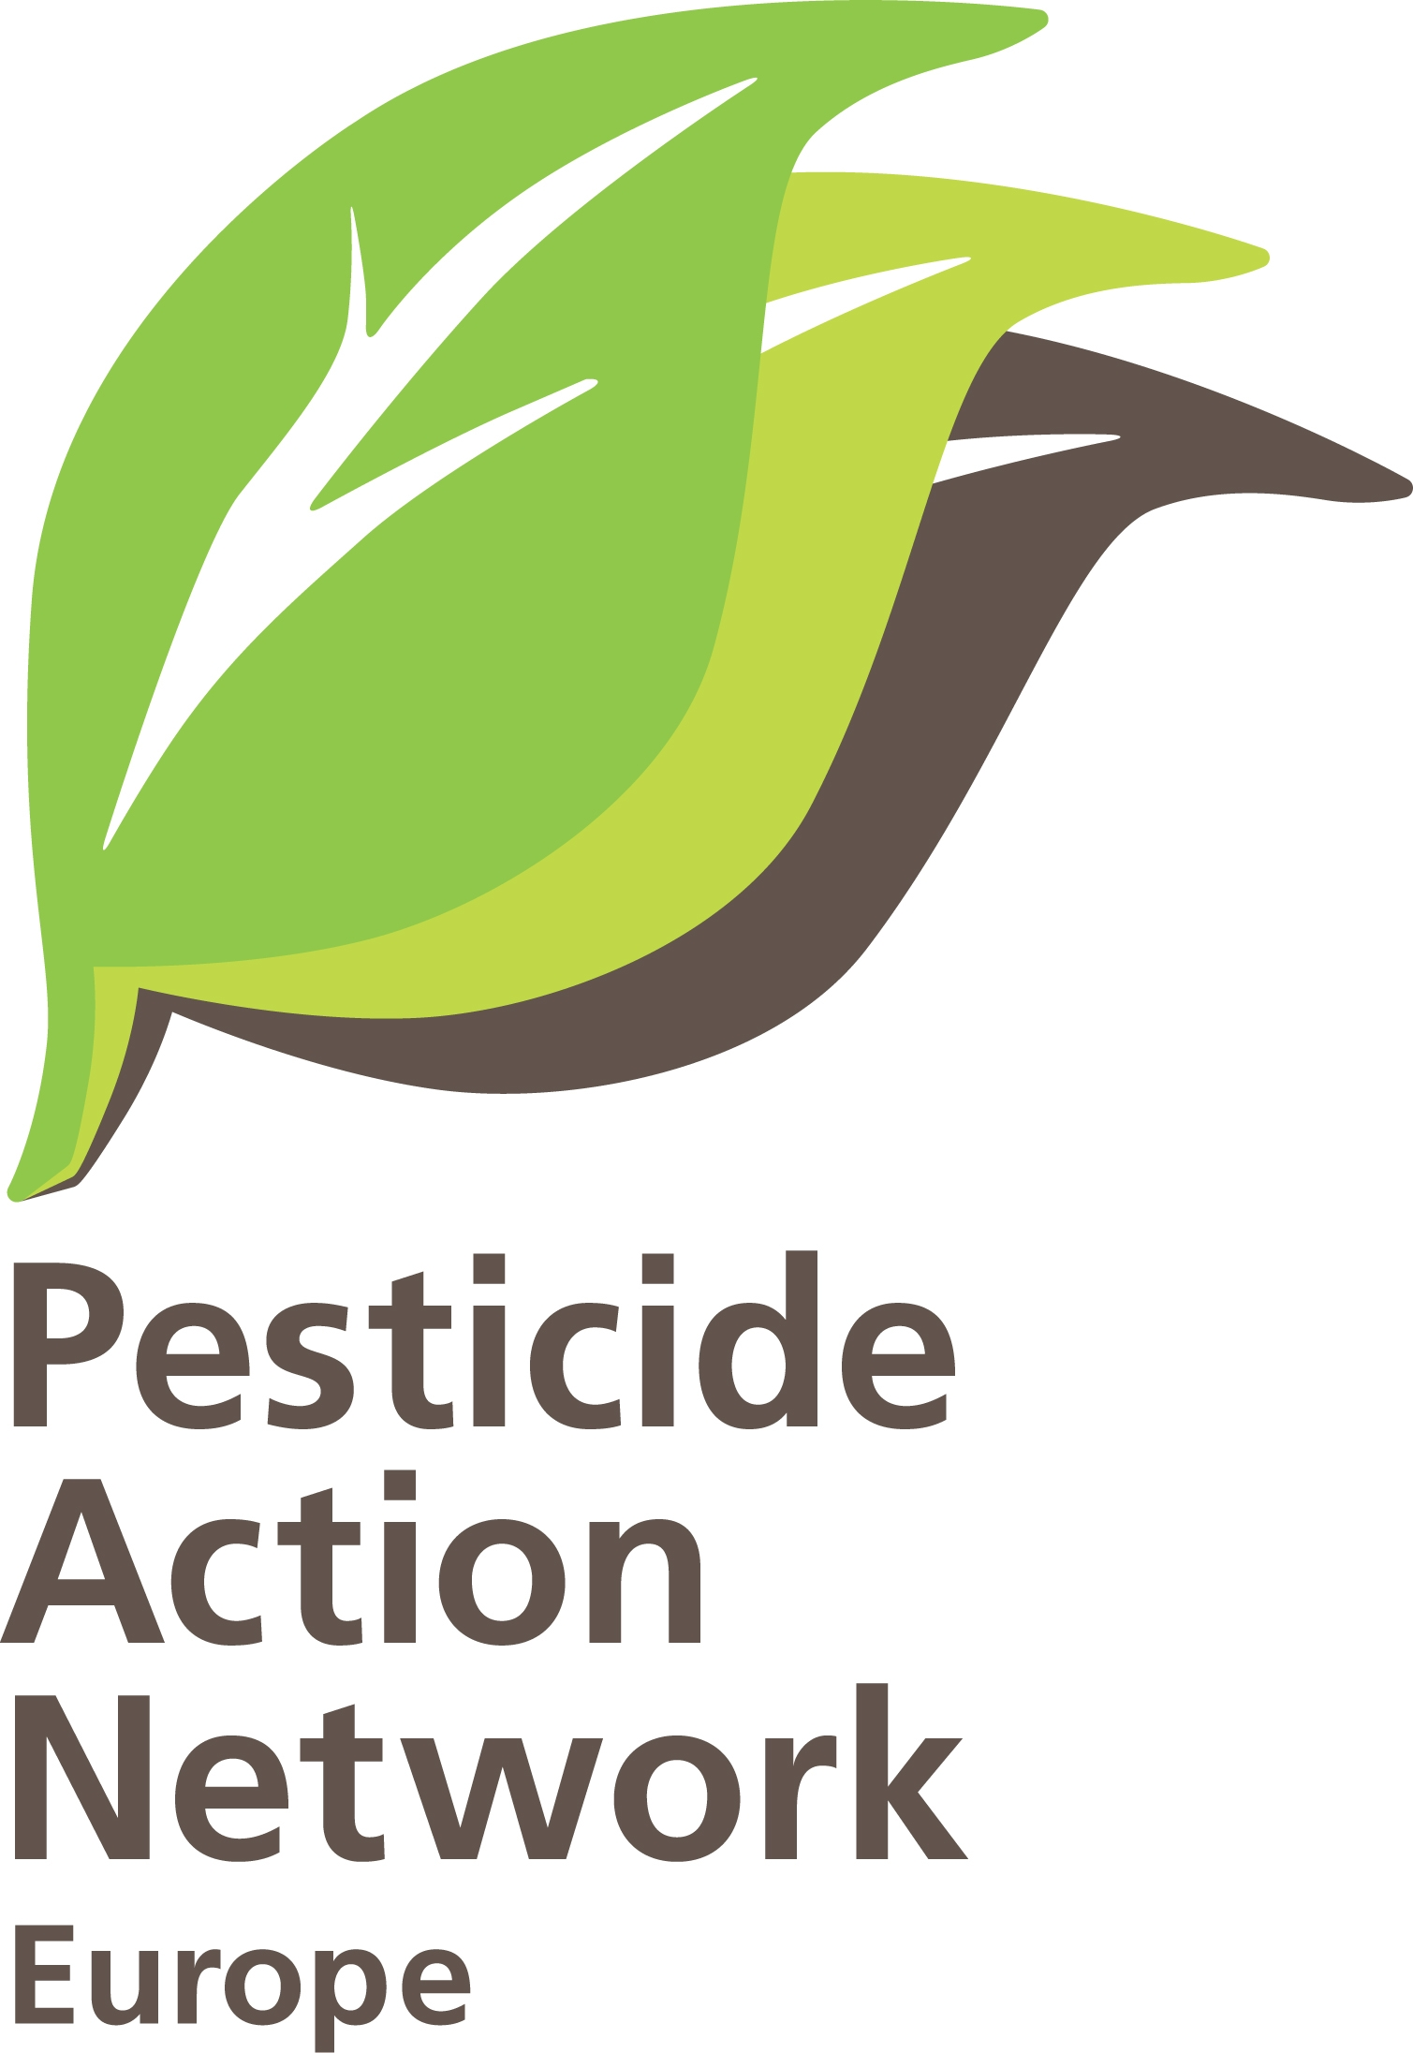 | PRESS RELEASE: Pope's blessing for the bees  Pope Francis received a representative of the anti-pesticides European Citizens' Initiative "Save Bees and Farmers"

Pope Francis received today Annemarie Gluderer, the representative of the European Citizens Initiative (ECI) “Save Bees and Farmers”, to express his support for efforts to protect bees from the dangerous effects of pesticides.

Upon request by the Italian representative of the ECI, the Vatican has decided to support and attract attention to our initiative and to ask the European Commission for a synthetic pesticide-free and bee-friendly agriculture within 15 years. Annemarie Gluderer, an organic farmer and victim of pesticides from South Tyrol (Italy) was received this morning by Pope Francis.

The trip to Rome began on 30 August and has stopped in many different Italian towns to promote a pesticide-free future.

Over the years, Pope Francis has regularly insisted on the importance of preserving and respecting nature.

Natalija Svrtan, campaigner at PAN Europe said: “The support of the Catholic Church is a recognition that the asks of our ECI are in line with the values of Catholicism. We are confident that this event will bring further support to our initiative. It is time we stop opposing food production and environmental protection”.

"Save bees and farmers" is a European Citizens Initiative that aims to collect 1 million signatures throughout the EU. The over 200 organisations alliance has until 30 September to collect the needed signatures. Over 750000 signatures have been collected up to now.
The initiative has three main asks:
1. Phasing out synthetic pesticides (reduction by up to 80% by 2030 and ban on pesticides in EU agricultural production by 2035)
2. Restoring biodiversity in agricultural environment
3. Supporting farmers in the transition to organic farming

For further information, contact:

Natalija Svrtan
Campaigner
natalija@pan-europe.info
+32 23186255

Pesticide Action Network Europe (PAN Europe) was founded in 1987 and brings together consumer, public health, environmental organisations, and women's groups from across Europe. PAN Europe is part of the global network PAN International working to minimise the negative effects and replace the use of harmful pesticides with ecologically sound alternatives.
For further information contact: Henriette Christensen, henriette@pan-europe.info

http://www.vatican.va/content/francesco/en/encyclicals/documents/papa-francesco_20150524_enciclica-laudato-si.html

