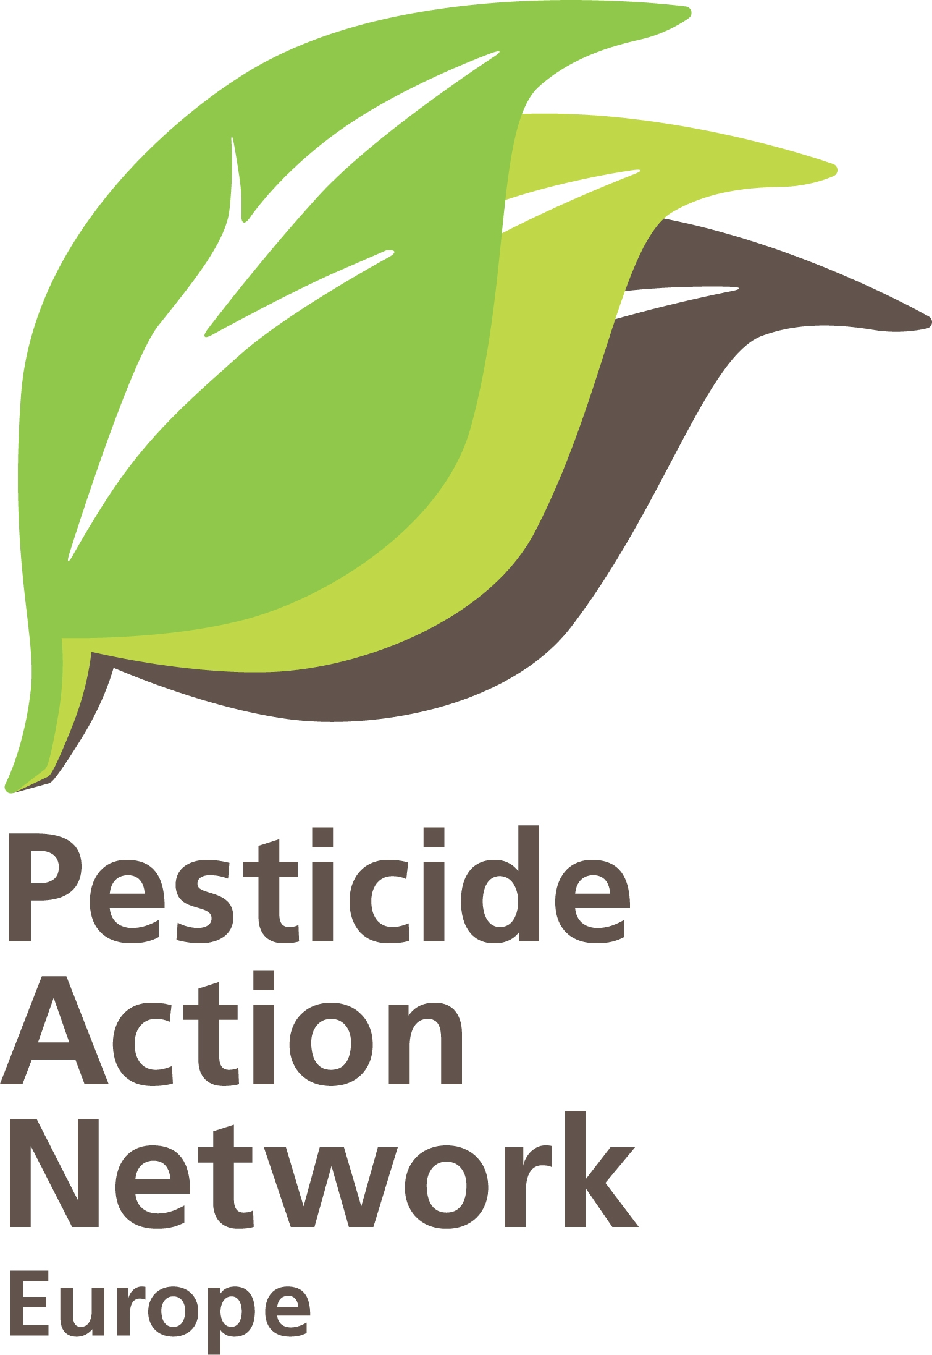 | Implementation of the pesticide Regulation at European and national level  Brussels, 24-09-13.  Contact : Hans Muilerman, hans@pan-europe.info, tel. 0031655807255

To: Mr. Tonio Borg
European Commissioner for Health and Consumer Policy
European Commission
B-1049 Brussels.

Concerning : Implementation of pesticide Regulation 1107/2009.

Dear Commissioner Borg,

Pesticide Action Network Europe (PAN-E) was commissioned by the Dutch ministry of the environment to evaluate the work of Dutch authorisation body Ctgb, especially regarding the protection of the environment. The reason for this was a discussion in Dutch Parliament about a 'race to the bottom' when the chair of Ctgb proposed to drop several elements of the authorisation protocols to be more "competitive" with authorisation bodies in other Member States. The reason for this desire to be competitive is the provision in the Regualtion 1107/2009 that pesticide applicants have the right to chose for a Member State and -obviously- will chose for the Member State causing the lowest costs in terms of required experimental studies and delivering the easiest access to the market. We are happy to send you a copy of the final report with a summary and the conclusions in english.
European Regulation 1107/2009 provides that national authorities have to ensure –based on proper research by industry on the local crop, animal, situation and climate- that there is a reasonable certainty that no unacceptable effects on the environment occur, not on birds, not on bees, mammals nor waterorganisms after the use of pesticides. The survey of PAN-E shows that the responsible Dutch body Ctgb generally does not request specific studies for Dutch crops and Dutch local situations to assess the adverse effects of pesticides and concludes that all studies in any other Member State count as well.
For instance, results of studies regarding the insecticide Fipronil in France used on sunflowers were considered applicable for the Netherlands -while sunflowers are not grown in the Netherlands- and considered applicable for all Dutch crops. Additionally, in many authorisations Ctgb does not request studies from the industry but accepts assumptions and reasoning of industry as a solid evidence of no harm. This is the case for the fungicide Fenpropadin -just as for several other pesticides- where Ctgb accepts all claims of no harm from the applicant without requiring any experimental studies. Also the latest European guidelines to protect the environment are not used by Ctgb and in stead outdated unscientific models and data applied which underestimate risks to a large extent. An extreme example of this policy is the herbicide Glufosinate showing "high risks" for birds and mammals according to European Food Authority EFSA, while Ctgb completely ignores these risks and fails to use the proper 2009-Guideline. The guideline for birds was never used by Ctgb at all. Ctgb also doesn't impose mitigation measures for the environment such as buffer zones. For the fungicide Folpet, for example, EFSA states a buffer zone of 5 - 15 meter is required; Ctgb doesn't impose any buffer zone at all.
Dutch Ctgb largely has a "copy & paste' policy on authorisations. They hardly request any experimental studies and do not add much to the European dossier of pesticides. One can wonder what 130 people in a Dutch office are doing while they do not live up to their mission to protect the environment and asses local situations. The belief that a general European level of protection (data extracted from the European dossier) is sufficient to protect Dutch environment is based on nothing, certainly not on experimental data.

On the background of this is the European approval process where Member States decided a few years ago that pesticides will not be banned on European level solely because of environmental reasons (the recent moratorium on neonicotinoides can also not be considered as a ban). Representatives of DG SANCO confirmed that this is the current situation in a meeting we had on 04-09-2012 with DG SANCO staff and MEP Staes. SANCO staff explained that Member States argued that a ban on European level based on environmental considerations was not acceptable because they might be able to find on national level certain situations and conditions of 'safe use' were an authorisation could be acceptable.

In our PAN report on "resubmission" we showed that based on this decision in the Standing Committee on Phytopharmaceuticals, dozens of pesticides with „high risks” for birds, mammals, bees -as concluded by Food Authority EFSA- are approved without any justification to show that the effects are acceptable. We feel this is dismissing the legal requirements on a routine basis and a grave violation of the precautionary principle.

Now the approval system is undermined on European level, the next question is if the Member States do their work properly and really assess if the effects are acceptable for the environment based on proper data. We discussed this in the meeting of 04-09-2012 and SANCO-staff member Mr. Poudelet stated it is not the job of DG SANCO to find out if the Member States do their work properly but the job of NGO's such as PAN-Europe. He stated that only if PAN-Europe manages to prove implementation problems at national level, DG SANCO will act.

While it is simply impossible, given the resources of PAN-Europe, to do the monitoring of the work of all Member States on pesticides, we feel it is also unjustified. DG SANCO has to play its role here and monitor if the environment is really protected against the harms of pesticides or that just cosmetic decisions taken nationally. We are however happy to present you at least the monitoring data from one country and hope you will act as promised.

The survey of PAN-E now indicates that the member states and their ministries of agriculture were not serious in protecting the environment and respecting the European rules when they voted for blocking any ban of a pesticide on European level solely because of environmental reasons. European rules are signed for by these same member states but it looks like it is just serving other interests than protection the environment.

We hope, Mr. Borg, you will take your responsibility and act in the Dutch case. We also invite you to do more survey in other Member States to find out if the environment is protected (check decisions, check mitigation measures if available including enforcement) and are happy to help you.

We are looking forward to your reaction,
Sincerely yours,
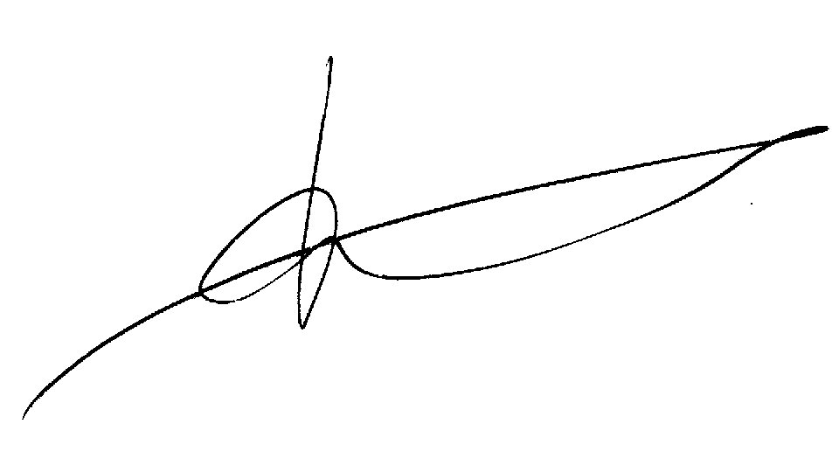

Hans Muilerman.
PAN Europe.

College voor de Toelating van Gewasbeschermingsmiddelen en biociden (Committee for the authorisation of pesticides and biocides)
Ctgb is only partly to blame for this because Dutch ministry of agriculture doesn't allow them to use the latest European accepted guidelines
This of course doesn't answer the question how the legal requirement from 1107/2009 to "have a reasonable certainty that there are no unacceptable effects on the environment" are met
PAN report on resubmission

