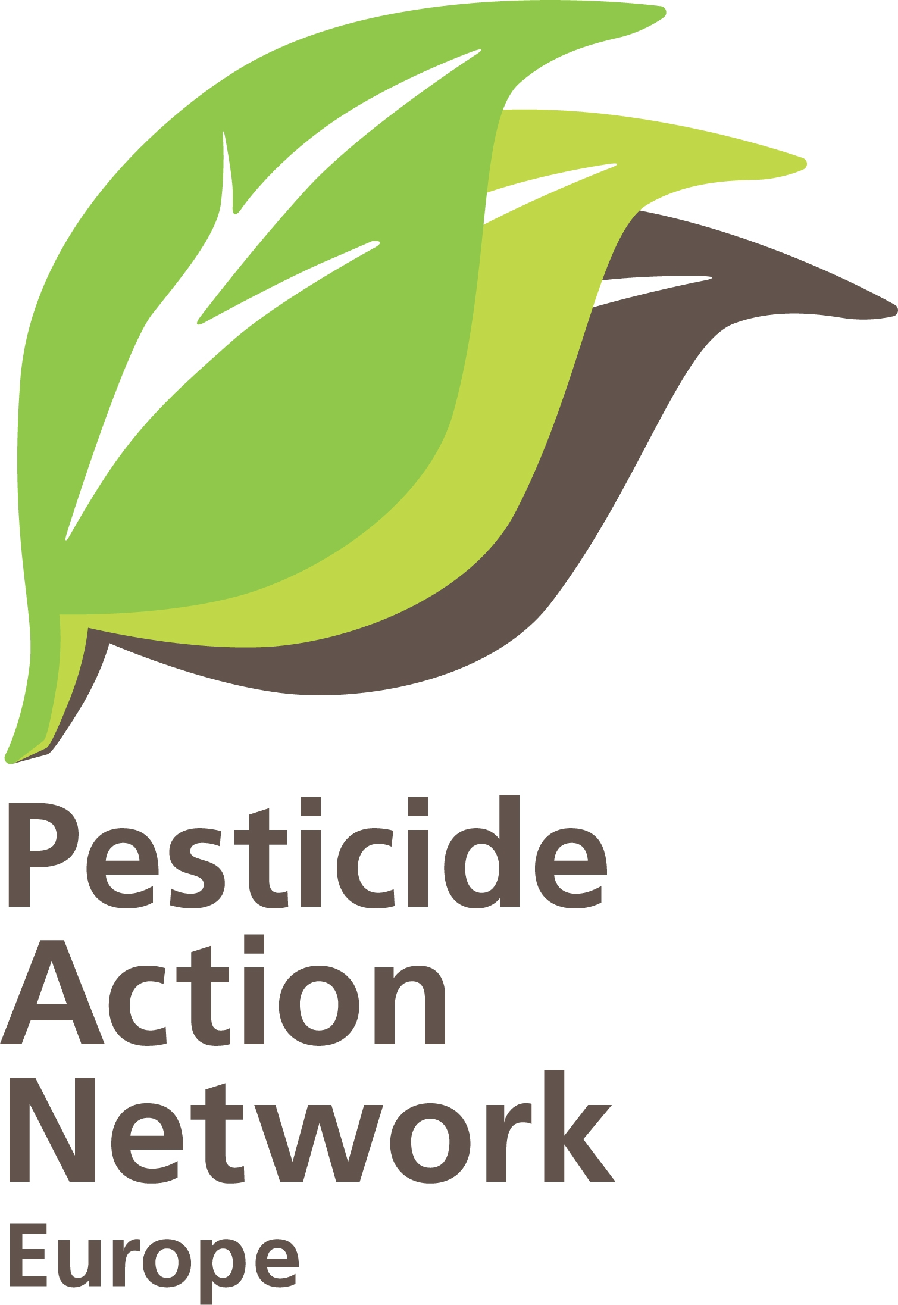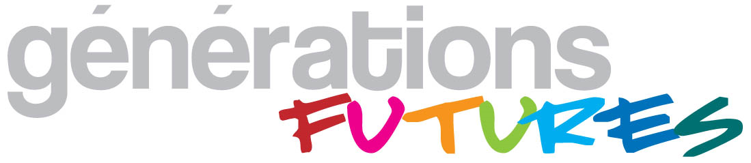 | Use of derogations for the authorisation of pesticides in EU Member States.  Brussels, 26-01-2011  PAN-Europe  Hans Muilerman.

To:
Mr. John Dalli
European Commissioner for Health and Consumer Policy
European Commission
B-1049 Brussels.

Concerning:
Derogation (Art.8.4 of Directive 91/414) for use of un-authorised pesticides.

Dear Commissioner, Dear Mr. Dalli,
We herewith send you the conclusions of our analysis on the use of the derogation-clause in Directive 91/414 for unforeseen danger and recommendations for an improvement of the situation (Report “Meet (chemical) agriculture: The world of backdoors, derogations, sneaky pathways and loopholes”, plus Excel annex).

In this report we show a sudden explosion in the use of derogations based on Art. 8.4. From 2007 to 2010 Member States derogations went up to over 500%. The 321 derogations granted in 2010 include 152 different active substances, making the derogation to a serious route of use of pesticides and serious health and environmental concern.

We have the strong impression of misuse of the derogation. The sudden rise (fi. France from 0 to 74 in 2010) sounds more like a legalisation of illegal use than of 74 cases of sudden `unforeseen danger`. It is hard to believe `unforeseen danger´ went up from 6 to 54 cases in Greece in 2010 or from 1 case in 2007 to 31 cases in Portugal. Looking at the derogations fi. the use of soil fumigants cannot be called an “unforeseen danger” given the monocultures used. Austria grants derogations for more or less the same chemicals every year, it is hard to understand why this is because of a “unforeseen danger”.
The derogation can only be granted if the unforeseen danger cannot be contained by other means. For the many insecticides and herbicides granted a derogation, it is questionable if a serious assessment of other means (chemicals, but also biological control and integrated pest management) is made.

The report also questions the transparency of the procedure to get to derogations and questions if all procedures from Art. 8.4 and 19 are done in a proper way. We therefore ask you to send us for the 94 cases of derogations granted as revealed by the summary report of the Standing Committee meeting of 28 and 29 September 2010 and the 76 cases of derogations granted as revealed by the summary report of the Standing Committee meeting 27 and 28 October 2010, the following information:
- the justification of the different Member States in these different cases of “unforeseeable danger”, Art.8.4;
- the justification of the different Member States in these cases of “cannot be contained by other means”, Art. 8.4;
- the “limited and controlled use” in these cases, Art.8.4;
- the consumer risk assessment done and the food standard set in these cases,
- the mitigation measures taken in these cases,
- a draft of the measures to be taken, submitted by Commission to the Committee, in these cases, Art.19, and
- the opinion delivered by the Committee on these draft measures, Art.19.

We recommend you to make the procedures and decision-taking much more transparent. Citizens and stakeholders in Europe have every right to get the information on applications, justifications and measures before the decision is taken as well as the discussion in the Committee, and not being confronted with a “fait accompli”. This will also help to get to a balanced outcome and to more trust of the authorisation system from citizens.

We also recommend to make the derogation system (and other available loophole constructions) as closed as possible, and unforeseen danger limit to real unforeseen danger. If farmers use management systems with outdated practices like monocultures, vulnerable varieties, and a lack of prevention, this derogation should never be applied. The wide application of this derogation system with 321 unforeseen dangers in 2010 and 152 un-authorised active substances adds risks to human and the environment, helps to keep outdated practices in place and stops innovation to sustainable practices.

We hope for your support,
Best regards,
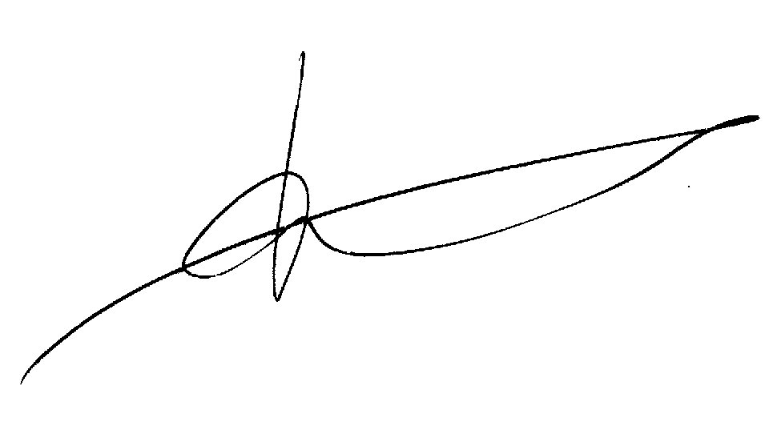

H.Muilerman.
PAN-Europe.
Also on behalf of F.Veillerette,
Génération FUTURES.

This application for access to documents is made under Regulation 1049/2001 of 30 May 2001 regarding access to European Parliament, Council and Commission document (Public Access to documents EC Regulation 1049/2001) and EC Regulation 1367/2006 of 6 September 2006 on the application of the provisions of the Aarhus Convention on Access to Information, Public Participation in decision-making and Access to Justice in Environmental Matters to Community Institutions and bodies (Aarhus EC Regulation 1367/2006).

