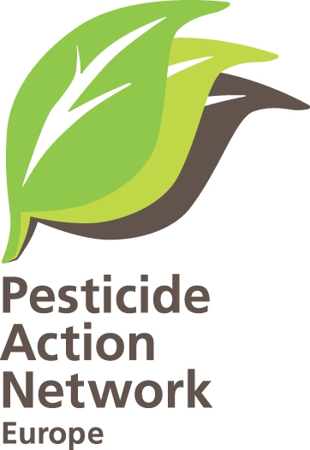

Brussels, 21 December 2010

Reg . : 14th December- putting the focus on the Sustainable Use of Pesticides Directive

Dear Minister,

The 14th December marks the date for crucial deadlines in the implementation of the Directive 2009/128/EC establishing a framework for Community action to achieve the sustainable use of pesticides :

- One year from now, by 14 December 2011, Member States have to bring the directive into accordance with their national law (article 23), and
- Two years from now, by 14 December 2012, have to communicate their National Action Plan (NAP) to the Commission and to other EU Member States (article 4.2).

These deadlines might seem far away, but there is considerable work that Member States need to prepare in order to meet these deadlines for the Sustainable Use Directive (SUD)(see details in the attached annex).

Pesticide Action Network Europe (PAN Europe) will be following closely the progress made by Member States over the next two years and helping our members play an active role in stakeholder forums on the SUD in their countries. We will recognise and give credit to good practices and serious progress and encourage more countries to take up good SUD practices, as well as highlighting disappointing progress or lack of MS commitments.

Pesticide Action Network Europe (PAN Europe) has taken active part in the stakeholder development of the SUD since 2002. Over the last year we have compiled numerous examples of positive actions already taken in some Member States in reducing pesticide hazards, risk and use in agriculture, public spaces and the amenity sectors. We have pleasure in sending you a copy of our Best Practice manual for Sustainable Use of Pesticides: Implementing a National Action Plan. This publication aims to stimulate all Member States to take a proactive role developing ambitious National Action Plans with quantitative pesticide reduction targets, clear time tables and concrete actions. This document can be downloaded from http://www.pan‐europe.info/Resources/Reports/NAP_best_practice.pdf.

PAN Europe aims to make this NAP Best Practice manual a ‘living’ document, as a starting point for inspiration, and we are looking for new and interesting examples and for information on new measures taken. Please also let us know if you think that there are better examples than the ones mentioned in our document.

While there is wide variation among the 27 MS on pesticide use measures, PAN Europe’s current assessment is that no Member State today has a complete NAP yet and there is room for improvement everywhere. We therefore ask you to help us in the process of working together for an effective SUD implementation across Europe, providing us with the following information:

- How are you securing that the different perspectives of all stakeholders involved in the NAP process are represented in the NAP? How are you securing a transparent process?
- What are the priority needs and measures you have identified for the NAP in the context of your country? What targets for pesticide reduction are proposed?
- Will buffer zones be part of the NAP package in your country? If you already include buffer zones, do you plan to expand these?
- Are pesticide-free parks on the agenda or other measures for reducing pesticide exposure in public places?
- Are crop-specific IPM standards already defined in your country? What other measures do you plan for helping more farmers adopt more effective IPM strategies?
- How will you communicate NAP measures with farmers? And with other pesticide users?
- Do you have pesticide poisoning information centres already in place? What other measures do you plan for informing the public about reducing pesticide exposure and harm?
PAN Europe also arrange meetings allowing stakeholders to exchange experience at practical level, identify problems and solutions, and together discuss ways forward. In 2011 these will focus on non-chemical pest management methods and we would be pleased to invite your country’s experiences in these.

I take this opportunity to wishing you all a merry Christmas and a happy new year.

Sincerely yours,

Henriette Christensen
Senior policy advisory of PAN Europe

