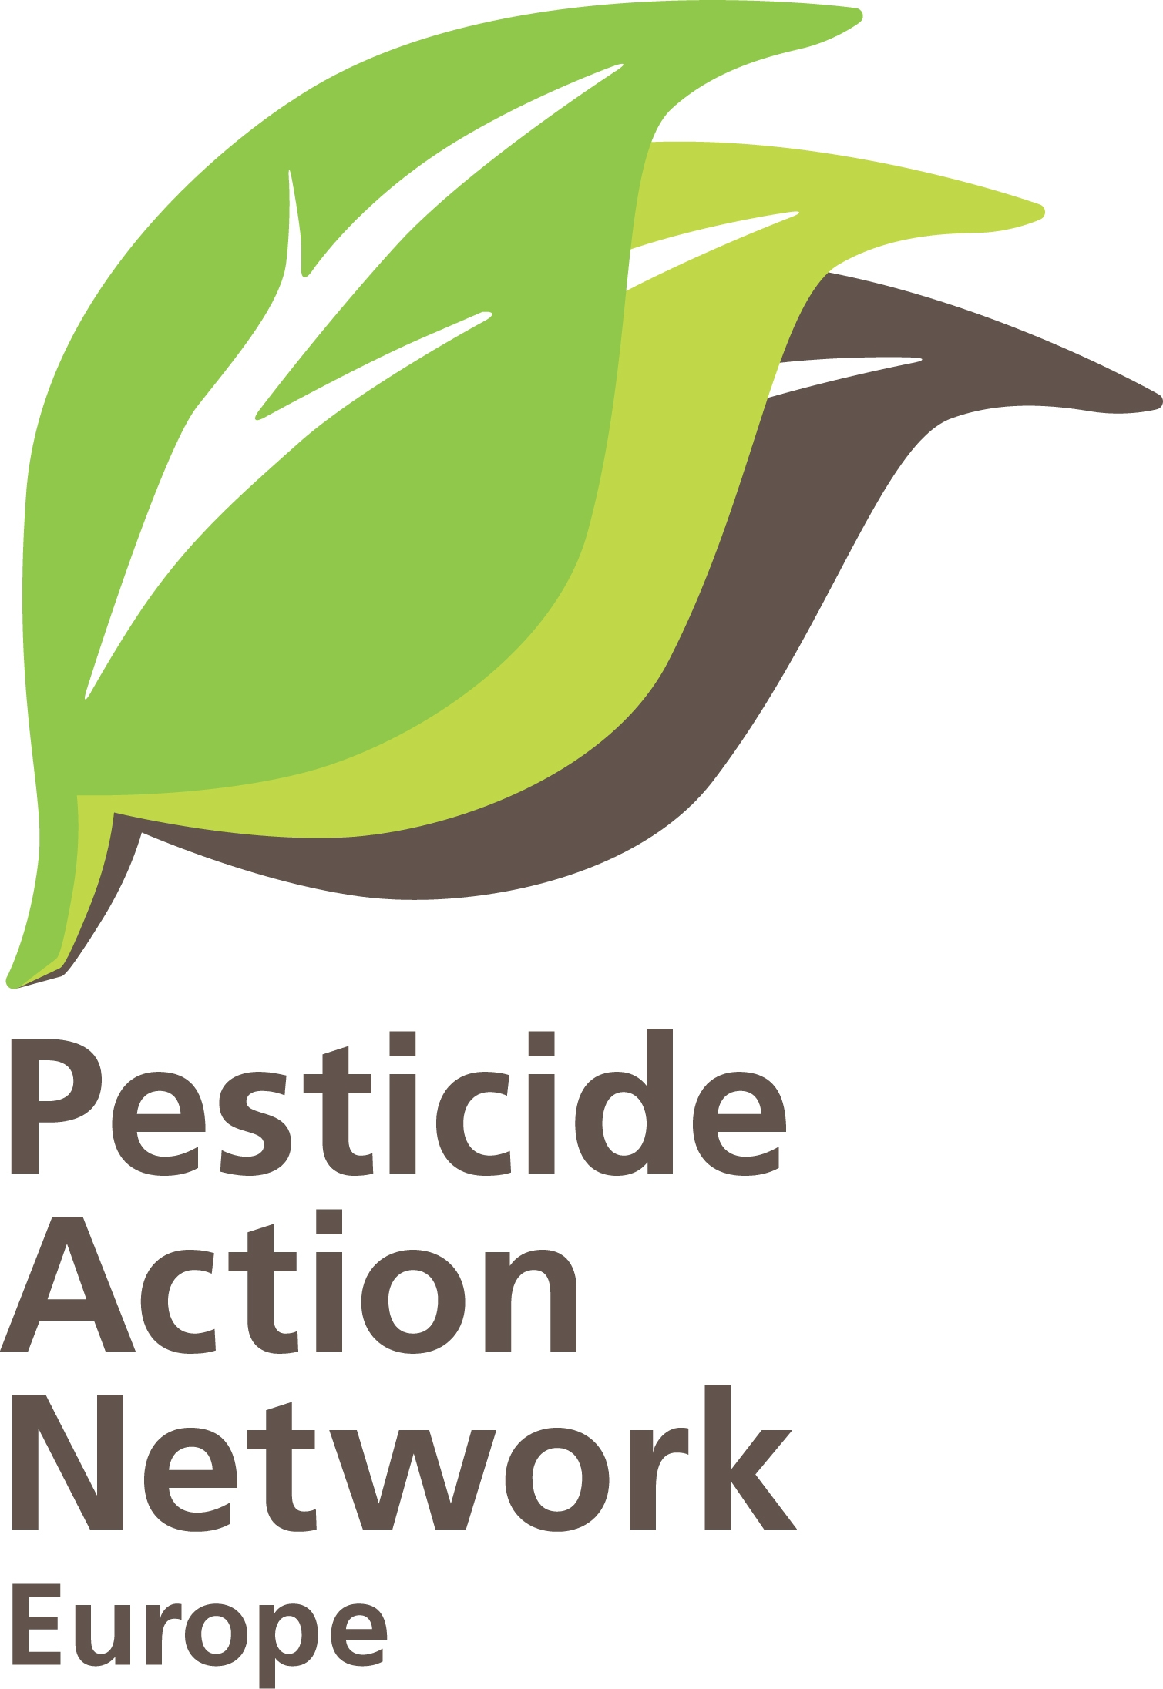 | Request for access to documents  Brussels, 10th of November 2010  PAN-Europe/ ClientEarth,  H.Muilerman/ V.Buonsante

European Food Safety Authority
Executive Director Mrs. Catherine Geslain-Lanéelle
Largo N. Palli 5/A
43121 Parma
ITALY.

Concerning: Request for access to documents related to draft guidance on the “Submission of scientific peer-reviewed open literature for the approval of pesticide active substances under Regulation (EC) No 1107/2009”.

Dear Mrs. Geslain-Lanéelle,
EFSA recently submitted a draft guidance to the internet for public consultation on the submission of scientific peer-reviewed open literature for the approval of active substances of pesticides. We welcome this kind of consultations to involve the general public in European decision making and we submitted our comments in early September 2010 to your website.
We however think the consultation could be strengthened much by giving more information on the way this guidance was developed and who contributed to the guidance. We saw the meeting minutes of AMU on the EFSA website (http://www.efsa.europa.eu/en/amuwgs/documents/amuguidance.pdf) but these minutes give us only very limited information. Full transparency will help decisions to be developed on better democratic principles and subsequently on more acceptance of citizens of Europe.

We therefore request the following list of documents:
- the original question-document (EFSA-Q-2009-00827) leading to the development of the (draft) guidance. We like to get the full document and any annexes if there are.
On the request of EFSA (page 4 of the draft guidance) to the Assessment Methodology Unit (AMU), through a self-tasking mandate, to develop a guideline:
- we like to get the written decision document from EFSA management for this request to AMU,
- we like to receive the full project description of this work of AMU (EFSA output type, timelines),
- the mandate and the written decision, memo’s or other documents showing the full list of tasks and people of AMU or invited external experts who are commissioned to do the development the guideline.
On the draft guidance (page 4) where it is stated that “close coordination and cooperation with the PRAPeR Unit are recommended…..”, we like to get all documents showing how this close coordination and cooperation is performed:
- the EFSA project outline document from management to PRAPeR,
- EFSA management decisions from management to PRAPeR on tasks and involved people,
- all invitations send from EFSA/AMU to PRAPeR on cooperation and coordination on this guideline,
- meeting documents from EFSA/AMU to PRAPeR, (all invitations, all minutes, all presence/absence lists),
- all written feedback from PRAPeR to EFSA/AMU(documents, memo’s, E-mails).
On the working groups established by AMU (page 5 of the draft guidance), and the 5 working group meetings organised, according to EFSA website, we like to receive
- all invitations send to participants of the working groups send from EFSA/AMU to participants for every individual meeting including the agenda,
- the full minutes of every meeting of the working group (not only the minutes on the website without much content) made by EFSA/AMU or another participant of the working group
- the presence/absence lists of every meeting made by EFSA/AMU or another participant
On the documents put forward by EFSA/AMU or other participants in the meetings of the working group (amuguidance.pdf), we like to receive:
- the document on the structure of the guidance (meeting 1);
- the draft guidance (meeting 2) as well as the documents outlining tasks and deadlines;
- the draft guideline send to PPR and PSC (meeting 3) as well as the documents outlining tasks and deadlines agreed in this meeting;
- the full invitation documents send from EFSA/AMU to the members of PPR and PSC (meeting 3);
- the full feedback documents (E-mails, memo’s, letters, or other document including names of those sending feedback) received from PPR and PSC members to EFSA/AMU (meeting 4);
- the feedback documents (E-mails, memo’s, letters, or other document) received from working group members (meeting 4) in the ‘written procedure’ mentioned there;
- the guidance agreed at the 5th meeting.

Additionally we request EFSA to draw up a detailed list of all the documents in its possession in relation to the working group and its establishment.

This application for access to documents is made under Regulation 1049/2001 of 30 May 2001 regarding access to European Parliament, Council and Commission document (Public Access to documents EC Regulation 1049/2001) and EC Regulation 1367/2006 of 6 September 2006 on the application of the provisions of the Aarhus Convention on Access to Information, Public Participation in decision-making and Access to Justice in Environmental Matters to Community Institutions and bodies (Aarhus EC Regulation 1367/2006).

As you may be aware that the Lisbon Treaty expands the scope of application of Regulation 1049/2001 and of Regulation 1367/2006 on the application of the Aarhus convention to EU institutions also to the Agencies of the European Union, these Regulations prevail over EFSA’s rules on access to documents (i.e. Decision MB 16.09.2003). Please note that any exception to the right to access information must be interpreted restrictively and the Jurisprudence of the European Court of Justice (joined cases T-391/03 and T-70/04; joined cases C-39/05 and C-52/05) foresees that the institution, in case of denial must:
  - State reasons for the decision;
  - Demonstrate that the disclosure of the requested document falls under the scope of an exception provided under Article 4 of Regulation 1049/2001
  - Carry out an examination that is “specific in nature” and “concrete” for each requested document.

With this application we respectfully request EFSA to grant access to the requested documents within the deadline foreseen by Article 7(1) of Regulation 1049/2001.

Yours sincerely,

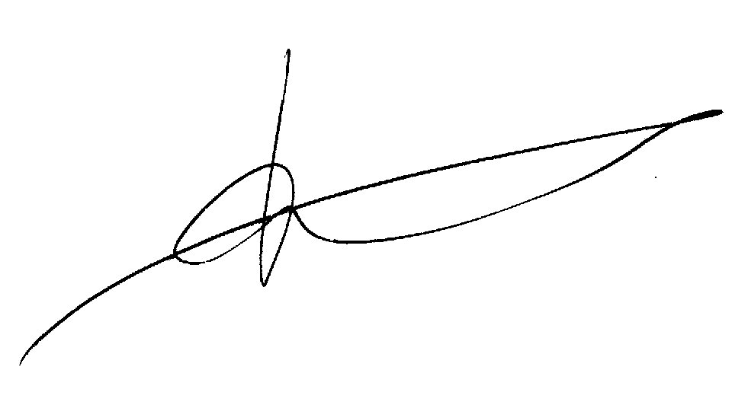

Pesticide Action Network Europe,
H. Muilerman.

Also on behalf of ClientEarth,
V. Buonsante.

(Suggested citation: European Food Safety Authority; Submission of scientific peer-reviewed open literature for the approval of pesticide active substances under Regulation (EC) No 1107/2009 (OJ L309/1, 21.10.2009, p. 1). EFSA Journal 20xx; volume(issue):xxxx. [40 pp.]. doi:10.2903/j.efsa.20NN.NNNN. Available online: www.efsa.europa.eu).

