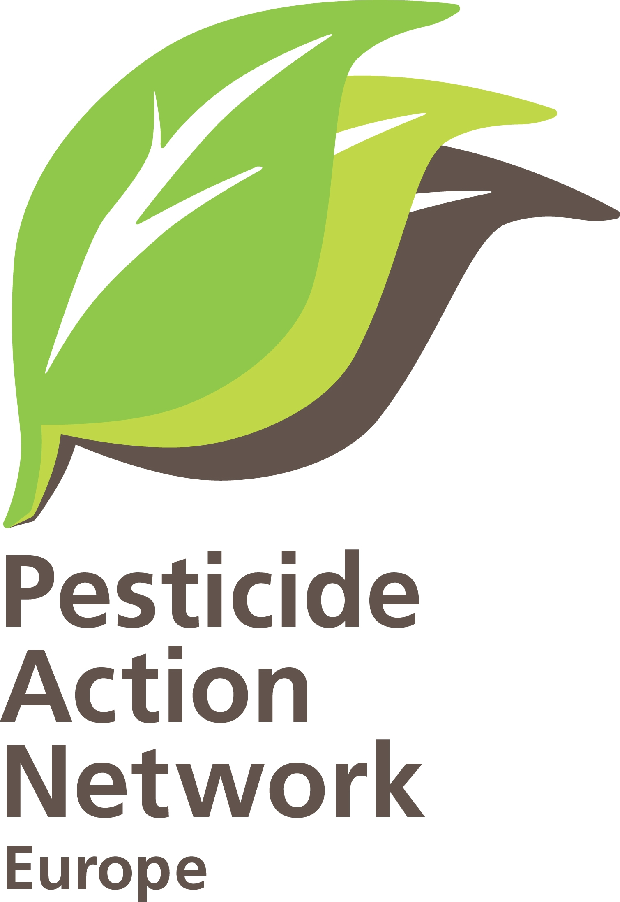 | PAN-Europe comments on EFSA draft guideline on the use of scientific peer-reviewed open literature.  Brussels, 06-09-2010.  Hans Muilerman.

EFSA undermines pesticide Regulation 1107/2009 on use of scientific peer-reviewed open literature.

For many years European government decisions on pesticides were based almost solely on industry toxicity tests. If these tests could be trusted after several major cases of fraud in the past, remains the big question.
In the new pesticides Regulation the European Parliament and Council decided we cannot rely only on industry’s tests and we need to take account of independent scientific peer-reviewed research in evaluating pesticides unwanted effects from now on.
EFSA, in its role of making guidelines for this provision, has published a draft for public consultation. It now turns out EFSA simply changes the Regulation by removing the ‘peer-reviewed open’ part in the Regulation and opens the gates for all kinds of non-reviewed grey studies and secondary research studies.
Worse by allowing industry to make a selection based on narrow criteria (only standard GLP tests), EFSA will cause independent scientific peer-reviewed literature probably to be denied at all.
Trusting industry to do this narrow selection and even the evaluation of research of others will probably be the final blow and ‘kill’ the provision in the Regulation entirely, thereby undermining a democratic decision.
EFSA states in the draft they want to prevent biased toxicological research to be included; the proposal of EFSA will lead to the contrary.

It is hard to understand why EFSA thinks to have the authority to change the text of the Regulation and redefine ‘scientific peer-reviewed open literature’ into ‘scientific literature’. The main argument EFSA uses is that scientific peer-review has its limitations (on rigour, validity and transparency) while reports of agencies and other grey literature could be important too. Peer-review has its limitations, but it is the only method that scientists have been able to create that promote the reliability of their data. It is the best we have to get to independent and scientific evidence.
In open science (published in scientific journals) the scientists involved and their quality (track record) is known, in peer-review high quality reviewers evaluate science before publication and can reject draft articles, publishing in scientific journals can lead to a scientific debate and everybody can repeat the science if they have any doubts.
On industry tests and agency reports (grey literature) this won’t happen, the quality of scientists is not known, there is no peer-review by independent scientists and any outcome or selection of outcome can be put forward (no control) and there is no scientific debate.
Grey literature can be anything. EFSA mentions report of agencies but it also includes meeting reports, secondary literature (evidence synthesis) and unpublished reports. It is hard to understand why EFSA changes a clear provision.

Making grey literature acceptable is a bad move of EFSA. Worse even is allowing industry –who is according to the Regulation obliged to do the job of searching scientific literature- to do a very narrow-focussed search of literature. Industry is allowed to do searches fi. on mutagenicity AND a specific defined form of (standard, GLP, Good Laboratory Practice) test design. No real interesting document will most likely be found. Scientists are generally not interested in repeating standard industry/GLP testing protocols. Standard testing protocols are many times decades old, miss new insights, could miss new endpoints, work many times with unrealistic high doses and could miss vulnerable life phases. For highly qualified scientists they are generally of no use. It is even questionable to call these tests science because it is routine laboratory testing.
The narrow-focus will deny real scientific evidence at large. If science would find something on mutagenicity but by another test, it would be qualified ‘not relevant’ by EFSA! This is giving no respect to scientists who have the objective of exploring new frontiers, not by following government protocols, but by being innovative and creative and developing new test systems. This forms the majority of scientific peer-review open literature (SPROL) in which highly qualified scientists try to find out what the evidence is and what the facts are. If they identify an adverse effect of a given pesticide it would be a signal for additional research or precautionary action. Denying this kind of work is not serving the public and not helping to prevent bias in risk assessment. Denying the signals from the scientific community will delay political action and put more people at harm.

As a conclusion the EFSA guidance,
- removes “open” from the definition in he Regulation, allowing all kinds of grey and unpublished studies to dominate the assessment
- removes “peer-reviewed” from the definition in the Regulation and an important control mechanism to keep science at a high standard
- removes in fact science itself by putting standardised GLP-tests on a platform, denying new scientific evidence and early warning signals
- altogether ‘kills’ the provision in the Regulation

The signalling role of science (like on asbestos, lead in gasoline, DES on pregnancy, DDT and bird dying, radiation and cancer, endocrines and reproduction) will be denied once again if EFSA gets its way with this guidance. Society will –again- not be protected if early warnings are disregarded. Science showing pesticides are much more toxic (have a far lower NOEC, No Observed Effect Concentration) will not be taken on board unless –in the rare case- proven by standard GLP-tests. Epidemiology studies, linking pesticides to certain disease (like pesticides and Parkinson) will be denied from further consideration. Public health will suffer from this narrow view of what science is.

Excluding industry bias in toxicity testing should –in stead- be the main objective of EFSA in their guideline. This is the reason why politicians put the provision for SPROL in the Regulation and EFSA should stop undermining a democratic decision. Industry testing has always been the weak spot in risk assessing. From the IBT-fraud in the eighties (bringing into question 15% of all pesticides in the US) and Craven Labs-fraud in the nineties, it was clear industry tests could be biased no matter if they used the Good Laboratory Practices (GLP, a management- and not a quality-system) or not. GLP creates the semblance of reliable and valid science, it actually offers no such guarantee. GLP specifies nothing about the quality of the research design, the skills of the technicians, the sensitivity of the assays, or whether the methods employed are current or out-of-date. GLP simply indicates that the laboratory technicians/scientists performing experiments follow highly detailed EU/OECD requirements for record keeping, including details of the conduct of the experiment and archiving relevant biological and chemical materials (see Myers JP et al, Environm. Health Perspect., 117, 309-315, 2009 also the extreme reliance of agencies on GLP). With GLP agencies incorrectly justify the “robustness” of industry testing and –most worrying at the same time- the inadequacy of peer-reviewed/published and independent studies. So rather than use this new mandate to rely less on industry data, EFSA plans to use the same tool, GLP, to keep on removing independent studies from consideration.

Industry bias is all around. For example, Lesser et al, looked at articles on the health effects of various soft drinks. The proportion of studies with unfavorable conclusions was 0% for all industry funded articles versus 37% for no industry funded articles (Lesser LI, et al. PLoS Med. 4(1): e5). Tobacco research is another well-known case of industry-bias where affiliations with the tobacco industry were 88x more likely to conclude that passive smoking is not harmful (Wise J, BMJ, 318: 1553, 1998). For pharmaceuticals, innumerable reviews have found that industry funding is tightly correlated with results favourable to the sponsor while the independent results are random (find both safety & risk and benefit & no benefit). Far fewer comparisons of industry vs. independent studies have been performed for industrial chemicals (including pesticides), but in the four known such reviews the same relationship is found: industry sponsorship seems to cause favourable results, while the independent literature finds both safety and risk [Bekelman JE, Yan Li and Gross CP 22 January 2003 'Scope and impact of financial conflicts of interest in biomedical research' JAMA 289(4):454-465; and Swaen GM & Meijers JM Sept1988 'Influence of design characteristics on the outcome of retrospective cohort studies' Br J Ind Med 45(9):624-9; and Fagin, D., & M. Lavelle, 1999 'Toxic Deception: How the Chemical Industry Manipulates Science, Bends the Law and Endangers Your Health'. Common Courage Press, 2nd Ed., Monroe, ME, USA; and FS vom Saal & C Hughes ‘An Extensive New Literature Concerning Low-Dose Effects of Bisphenol A Shows the Need for a New Risk Assessment’ Environ Health Perspect 113:926-933 (2005).].

PAN-Europe propose to completely rewrite the EFSA guidance and focus entirely on how to minimise industry bias. This means use the provision in the Regulation to force industry to find and include all scientific peer-reviewed open literature (SPROL) showing negative effects of the pesticide in their application and disregard anything not peer-reviewed and not published in a scientific journal where it can be debated and scrutinized. So no grey literature of national agencies which are in many cases based on industry information. And surely no meeting procedures like the many ‘scientific’ meetings industry organises let alone information on websites. And above all no secondary research (re-interpretations, often statistical, of science of others) which creates the best opportunity for bias. The evaluation of the evidence is EFSA’s own role. The objectives for a search for science and assessment must be:
- collect all adverse effects in scientific peer-reviewed open literature
- just present all science, no selection, no commenting
- EFSA to do the evaluation of science

Very important is that EFSA makes clear rules to exclude industry influence in SPROL. Industry is already for a long time trying to get a better image by investing a lot in upgrading their tests to peer-review level. They even have ‘captured’ journals now (see “Doubt is their product”, David Michaels, Oxford University Press, 2008, former US administrator; also “Merchants of doubt: How a handful of scientists obscured the truth on issues from tobacco smoking to global warming”, Naomi Oreskes and Erik Conway, Bloomsbury Press, 2010. ) and many times industry hired specialized firms to reanalyse SPROL of independent scientists using statistical methods until arriving at the opposite conclusion and publish it (peer-reviewed) to make the original one controversial. Examples of these are the case of Atrazine and prostate cancer. After a publication on a high rate of prostrate cancer in a Syngenta plant producing Atrazine was published (P.A. MacLennan et al. Cancer incidence among triazine manifacturing workers, J. Occup. Environ. Med. 2002; 44 (11): 1048.), a firm working for Syngenta (Exponent Inc.) produced a study finding no relation (P.A. Hessel et al. A nested case control study of prostate cancer and atrazine exposure, J. Occup. Environ med. 2004; 46 (4): 379). After numerous studies on the relation between pesticides and Parkinson, Exponent Inc. produced a review for CropLife America claiming insufficient evidence (A.A. Li et al., Evaluation of epidemiologic and animal data associating pesticides with Parkinson’s disease, J. Occup. Environ med. 2005; 47 (10): 1059).

EFSA should make sure that any and all industry involvement in SPROL is made transparent and in no case industry-linked or –funded research is included in the collection. Re-evaluation of research (evidence synthesis), by industry or by consultancies paid by industry, should always be disregarded.

Finally PAN-Europe would like to know who was consulted in the making of this draft. Who exactly were the ‘external members’ the draft is talking about, who were part of telephone conferences and who participated from PPR and PSC?

