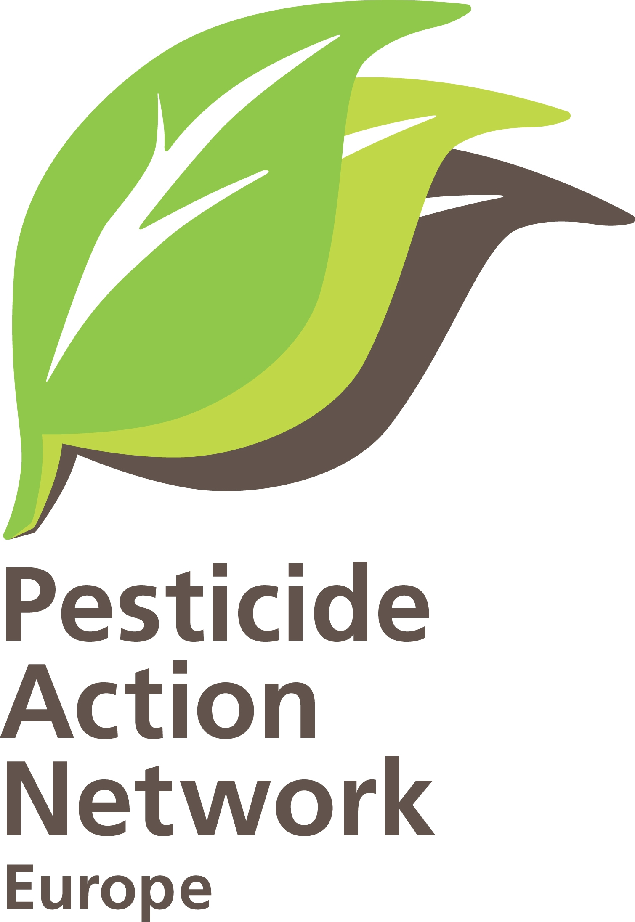
DRAFT PROGRAMME
PAN Europe Annual General Meeting
Brussels, 27-29 October 2010

Wednesday 27/10  morning  12h00  12h45  13h00  14h30  14h45  15h45  17h15  17h30  19h30 | Arrival of participants  Lunch  Joint Working Group on Chemicals and Biocides  Introduction (Hans Muilerman & Christian Schweer)  - Update on biocides: Biocide management in Europe  Introductory notes:  - Biocide regulation: Commission’s view, by Karola Maxianova, DG ENVI  - From PRBP to Political Agreement – Belgian’s efforts on biocide management, by Philippe Ruelle, FPS  - NGO activities on biocides, by Christian Schweer  What are the concerns and demands of PAN-members? What can PAN-members contribute on biocides next year? Which priorities share PAN-members concerning biocides? What is PAN’s “roadmap” on biocides?  Coffee Break  II. Horizontal topics  - Introductory note, by Hans Muilerman  Possible topics: use of science, endocrine disruption, data requirements, combination toxicity, substitution, cut-off, sustainable use, non-chemical alternatives, funding  On which to have a discussion now? / Which key questions and demands do PAN members have on these issues? / What does PAN want to follow and to achieve until when?  III. Update on implementation of pesticides  - EP’s opportunities for action, by Marie Foltmann,  assistant of Dan Jorgensen, MEP (16h45)  What are the concerns of PAN-members / What can PAN-members contribute on pesticide implementation next year?  Conclusion and establishment of 2011 working programme  End of the Working Group meeting  Dinner – 19h15 departure from the hotel for dinner
Thursday 28/10  9h00  9h30  10h00  10H30  12h15  12h30  13h30  15h00  17h00 | Working group on agriculture and supermarkets  Implementation of Sustainable use Directive – where are we?  - Best practice NAP, by Henriette  Round table : implementation at national level, timing and priorities  Grass roots activities to raise awareness of pesticides issues:  - SSP around the world, by Malissa Phitthayaphone MDRGF  - SSP in Belgium and Brussels, by Domken ADALIA  - Pesticide use and private gardens, especially kitchen plots, by Nick Mole  Roundtable: how can/should PAN E help?  EU policies  - Which Common Agricultural Policy Instruments can help to reduce pesticide dependency, by Henriette  Roundtable: how to get members involved  Can PAN E do more to ensure diversity in the food chain?  - ‘the IPM potential of biological control from greenhouse to open fields’ by Karel Bolckmans, Koppert  - ‘’PUERTO EXPORT S.A and ZERYA TEELT – should/could PAN Europe help to encourage more transability in the food chain by Stefaan Vanderhaeghe, Zerya  - PAN UK assisting supermarkets in developing pesticides list, by Stephanie PAN UK  - Natuur and Milieu assisting supermarkets in delivering IP products by Hans PAN Europe  - ‘Pesticides – nein danke’ campaign, by Daniela Hoffman Global 2000  Roundtable: the way forward  Conclusion and establishment of 2011 workprogramme  Lunch  Intervention by Ludwig Kramer on “Protecting the environment through law: the example of pesticides  General Assembly (internal annual meeting):  Ways forward for PAN Europe:  PAN Europe transferring to Brussels  How members can join the ASBL  The potential of individual membership  Activities:  2009/2010 PAN Europe activities  2011 workplan on Chemicals, Biocides, NIC  Budgets and accounts:  2009 accounts (for London office, and 2010-2011 budgets (for London and Brussels offices)  End of general assembly  Cocktail at PAN Head quarters Rue de la Pepiniere n1 – opening of the PAN Europe office by Cathrine Wattiez, Gretta Goldenman and Ron Kingham
Friday 29/10  10h00  12h00 | - The Red Mood in Hungary by Gergely Simon board member of PAN Europe  - PAN Europe policy fitting into the international PAN family by Gergely Simon board member of PAN Europe  - Linking pesticide policy to a wider food policy agenda by Dr David Buffin, Centre for Food Policy, School of Community and Health Sciences  Discussion  End of programme

ACCOMODATION
Ibis Brussels Centre Ste Catherine
Rue Joseph Plateau 2
1000 Brussels
Tel 32 2 513 76 20, Metro Line 1 Station St Catherine

VENUE
27th October (12h45 – 18h00) meeting will take place in Ibis Brussels Centre Ste Catherine conference room “Europe”
28th October meeting will take place in Abbaye du Rouge-Cloître/Rood-Klooster, meeting room Nature et Loisirs, Rue de Rouge-Cloître 4, B-1160 Auderghem (Bruxelles) , Tél. :02 660 55 from (9h15 to 17h00). Metro Line 1, Station Herrmann Debroux – Group departure from reception of Hotel Ibis at 8h15. From Metro Station to Rouge Cloitre 20 minutes walk
29th October (10h00 – 12h00) meeting will take place in Ibis Brussels Centre Ste Catherine conference room “Europe”.
Cocktail will take place on 28th October at 18h00 in PAN Europe asbl Office Rue de la Pepiniere B-1000 Bruxelles, Metro Line 2 Station Porte de Namur/Naamsepoort

How to reach Ibis Hotel
From the airport take the train to Brussels Gare Centrale / Station Brussels Centraal (Airport train station is on your right when leaving the international zone at level -2, cost 5 EUR, 12 minutes ) From Central station walk (800 M) or take Metro line 1 direction Erasme/Roi Baudouin and Stop in station St, Catherine
From Gare du Midi or Gare du Nord take Premetro Line and stop in Station De Brouckere

