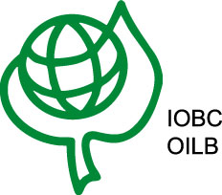
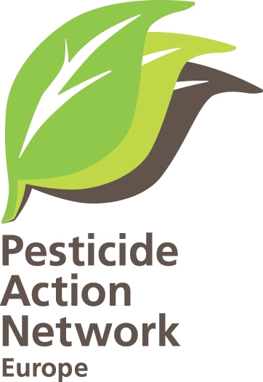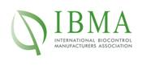

Conclusion of the high level symposium held on the 19 June 2012 in Brussels as a Commemorating the 50 years anniversary of Rachel Carson’s “The Silent Spring” on Integrated Pest Management - the way forward to Sustainable Agricultural Production

It is approximately 60 years ago that pesticides began to play a role in crop protection of agriculture. Only a few years later, problems with resistant pest organisms appeared and challenged industry and farmers. This was the first time that the limitations of relying to only one control method became obvious. These problems were the starting point of the new area of “re-thinking” the strategy of crop protection, giving birth to the idea of integrating several methods to protect a crop, i.e.to apply a combination of preventive means and control methods. The idea of IPM was born.

As a reaction of a blind believe in pesticides, a handful of thoughtful and progressive scientists from Europe founded the IOBC in 1956 with the aim to foster biological control methods and integrating them to crop protection systems. The very idea was to reduce overuse of pesticides, to prevent resistance build-up and to reduce toxic effects to the environment. In their first publications, they stressed already the importance of preventive methods and the development of biological control. In 1959, the 1st IOBC Working Group on “Integrated Control of Orchard Pests” was established. This WG is still very active today and has set the scene in orchard crop protection for over 50 years. Only three years later (in 1962) Rachel Carson published her famous “Silent Spring” which was a landmark making the world aware of the problems of pesticides. During these last 50 years, pesticides continued to play an important role in crop protection, and we continued to pollute our environment despite the fact that we all knew about IPM, biological control and other alternatives.

The principles of IPM were, at least in theory, promoted by all parties involved in crop protection. However, a really broad implementation into practice was not reached. A few pioneering farmers and organisations have adopted the ideas of IPM and IP and have made prove that it works.

Nowadays, we are in a unique situation in Europe with the new EC Directive (SUD) which has lifted IPM on the political scene that it deserves since long. This is the beginning of a new area and we, having fought since decades in favour of IPM, hope that January 2014 will be the start only of IPM implementation, and that a continuous development and improvement will follow later. IPM is a great opportunity for a more resource efficient and environmentally friendly agriculture, but it is a challenge at the same time. Implementing IPM is not primarily a technical challenge it is in the first place mental exercise for everybody. We have to learn to think in ecosystems, to understand the relevance of underlying mechanisms and to make use of ecosystem services and use these resources thoughtful in order to “achieve more from less”, meaning not only producing more but also have to produce better!
IPM means that farmers are faced to a constant evolution of crop protection approaches and methods as much as pest organisms and technologies to control pests, diseases and weeds are evolving. In the past, IPM was most often a reaction on problems and implementation took place when there were pressures coming from outside such as pesticide resistance, market access, environmental problems, governmental decrees. The future of IPM should be the reverse, proactive and progressive solutions should be thought through innovative partnership, and, as an economic incentive, while all farmers should apply basic principles of IPM, pioneering farmers should get a premium for the added value by IPM and IP.

IPM means that farmers are faced to a constant evolution of crop protection approaches and methods as much as pest organisms and technologies to control pests, diseases and weeds are evolving. In the past, IPM was most often a reaction on problems and implementation took place when there were pressures coming from outside such as pesticide resistance, market access, environmental problems, governmental decrees.

Though, for the EU to walk away and rely solely on Member States implementation and not require co-ordinated activities and follow-up would belittle the need for this ambitious legislation in the first place. Let us plan now to ensure we have the systems in place to best share the information with all stakeholders and work towards learning from each other throughout the implementation process.

The entire EU debate on innovation, growth, and resource efficiency must explicit target the pesticide dependency reduction under the slogan of "not only how to produce more, but also how to produce better". We jointly encourage the EU to ensure that:

The Sustainable Use Directive becomes fully integrated into all parts of the Common Agricultural Policy (CAP) and the CAP to start following an IPM logic based on delivery of agricultural practices and promotion of alternatives;

The European Innovative Partnership makes it mandatory for member states to offer IPM farm advises and seriously work for that local action groups are encouraged to work on holistic IPM systems.

Start debating the longer term need to start working on a specific regulations of biocontrol products, with authorization procedures being proportional to the risks.

Who are we – an innovative partnership consisting of:

IOBC/WPRS is an International Organisation of progressive European researchers and other knowledgeable people investigating the use of sustainable, environmentally safe, economically feasible socially acceptable control methods of pests and diseases of agricultural crops. Therefore IOBC/WPRS encourages collaboration in the development and promotion of Biological and Integrated Pest Management. IOBC/WPRS fosters research and practical application, training and information exchange, especially of all methods including biological control within an integrated pest management context. IOBC/WPRS produces guidelines for integrated production of agricultural crops, collaborates with different stakeholders to develop sustainable agricultural production systems and standardises methods of testing effects of pesticides on beneficial species with the aim to foster biodiversity and ecological services as a natural resource.
IBMA is the association of biocontrol industries producing solutions: microorganisms, macroorganisms, semiochemicals and natural products for plant protection. Based on long years of intensive research and development, the "Biocontrol industry" is now growing fast and can offer safe and cost- effective solutions to the entire food chain. IBMA was created in 1995 to represent the views of the developing biological control manufacturers, which are mainly SME’s with limited resources, research organisations, extension services, consultants, distributors, contributing to the development of biocontrol and participating in IBMA activities.
PAN Europe is an NGO working to minimise negative effects and replace the use of hazardous chemicals with ecologically sound alternatives. Our network brings together public health, and environmental organisations and women's groups from across 19 European countries. We work to eliminate dependency on chemical pesticides and to support safe sustainable pest control methods.

