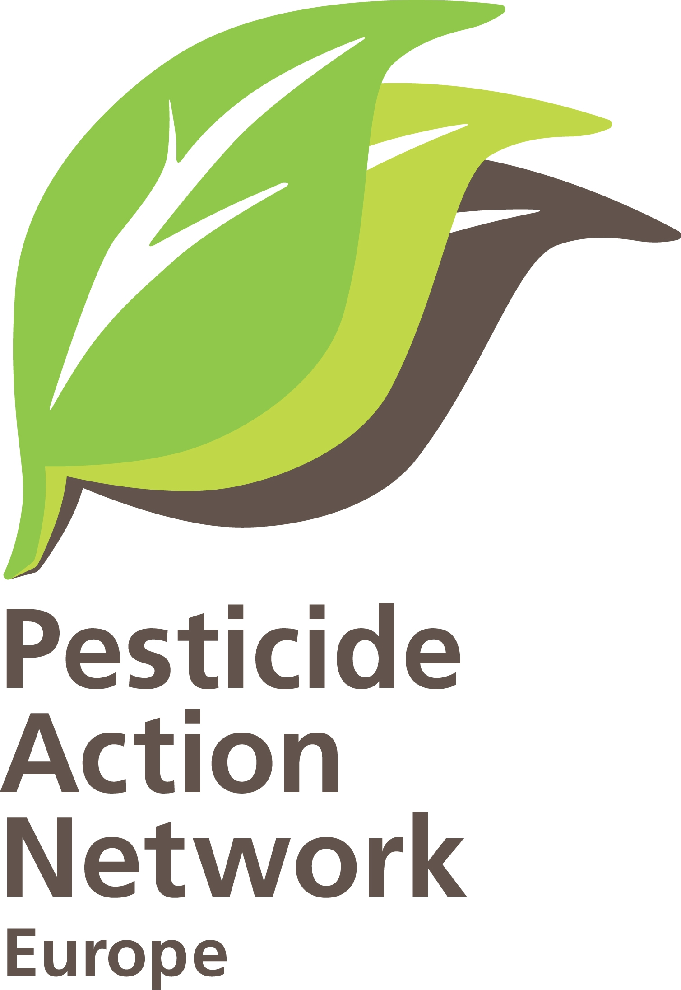 | Phase out of soil fumigation/ Ban on Metam Sodium.  Brussels, 02-1012011.  Contact : Hans Muilerman, hans@pan-europe.info, tel. 0031655807255

To: Mr. John Dalli
European Commissioner for Health and Consumer Policy
European Commission
B-1049 Brussels.

Concerning : Soil fumigation and Metam Sodium.

Dear Commissioner, Dear Mr. Dalli,
Soon you will decide what to propose to the Member States on the resubmission request for the soil fumigant Metam Sodium. We hope you will consider no other option than a full ban, just like you did in the case of the other soil fumigant 1,3-Dichloropropene. Our arguments are given below.

First of all Metam Sodium is a very dangerous chemical. Metam and breakdown product MITC are hepatoxic, immunotoxic, reprotoxic and a suspected carcinogen. Metam kills off many soil organisms like the useful earthworms, pollutes groundwater and might contribute to long-range pollution. People living close to fields which are injected with Metam or bystanders have a high risk for negative health effects. EFSA, in its peer-review on Metam, calculates that the safe dose is exceeded by bystanders and residents in 5 hours during application. The effects on the vulnerable like children is not calculated at all, but the safe dose must be exceeded much earlier given their body weight, while the extra vulnerability of children is still disregarded. Remarkably the EFSA calculation is based on exposure levels proposed by industry while in the same EFSA document (page 82/83) much higher exposure data are given by other sources, 10 x higher or even more. This could mean people are put at very high risks.

Secondly Metam Sodium can in no way be part of the future integrated pest management (IPM) which is to be implemented by your Directorate-General and Member States by 2014 (Directive 128/2009/EC). IPM is based on wide crop rotations and the use of resistant varieties while Metam functions to keep narrow rotations and monocultures in place and discourages the use of resistant varieties. Exactly the opposite. Also Regulation 1107/2009 states pesticides need to be properly used according to the principles of IPM.
We think given this provision in 1107/2009 and the connection to 128/2009, Metam should even not be considered for approval at all.

The “essential use” regime for Metam (2009/562/EC) is the current state of affairs in Europe and PAN-Europe made an analysis of the use by the 15 Member States applying for essential use (report attached). It appears that none of these 15 Member States works very hard on the obligation to find alternatives for Metam and also no-one of the 15 put in place an action plan as required by the Council Decision 2009/562/EC. This means the mindset in many countries is still focussed on traditional methods and practices and this will be a big hurdle to get IPM implemented.

We urge you to help IPM getting reality by not approving Metam Sodium and similar soil fumigants. A phase-out of these category makes IPM-measures like crop rotation and resistant varieties a necessity, which is given the mindset of several Member States the only option to make progress.
Apart from this, Metam will be far too risky for use for people living or staying close to the fields and especially the vulnerable. Additionally, soil biodiversity will be killed off and groundwater polluted.
We further ask you to enforce Council Decision 2009/562/EC and make sure the 15 Member States start developing serious action plan to change practices to alternatives and IPM.

We hope for your reaction,
Sincerely yours,
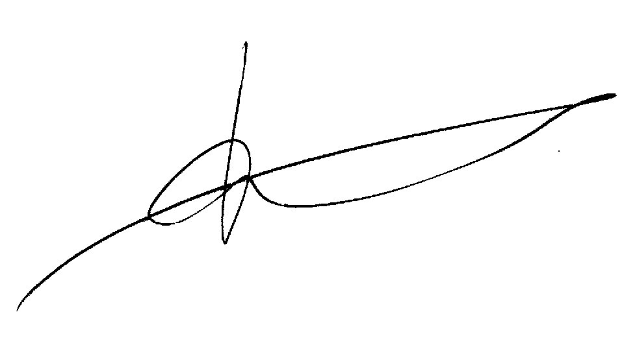

Hans Muilerman.
PAN Europe.

European Food Safety Authority; Conclusion on the peer review of the pesticide risk assessment of the active substance metam. EFSA Journal 2011;9(9):2334. [97 pp.].

