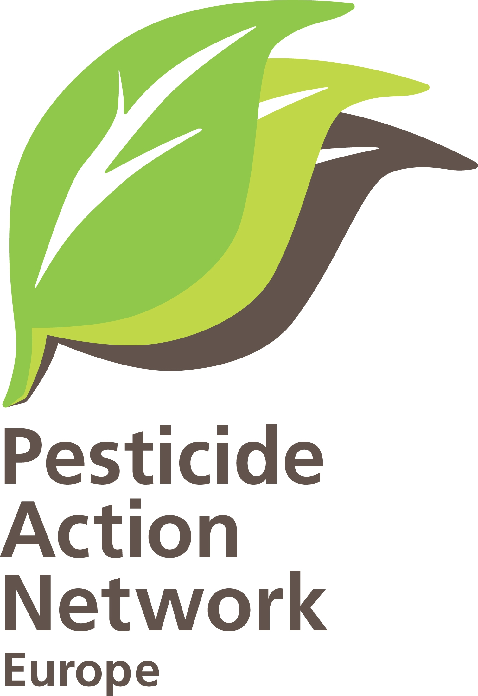

IMPACT ASSESSMENT ANNEX Ia
The number of endocrine disrupting pesticides that may cause damage to human health and should be regulated (1107/2009, Annex II, 3.6.5)

Introduction

Although the pesticide regulation (Regulation 1007/2009) was put into force in 2011 and mandates to regulate the use of pesticides with endocrine disrupting properties, the criteria that define endocrine disrupting pesticides are still missing. In June 2014, the Commission published a Roadmap that outlines the different options considered by the regulators for the definition, criteria and regulatory decision-making of endocrine disruptors. Most of the options considered fail to include all knowledge from the field of endocrine disruption research, as explained in PAN Europe’s position paper on the roadmap, and thus will inevitably jeopardize the effectiveness of the Pesticide regulation to protect human and the environment from exposure to chemicals that interfere with their hormonal system.

In the current report, PAN Europe has conducted a research to assess what will happen in the approval of pesticides, if the provisional criteria for endocrine disrupting pesticides are applied. As provided by Regulation 1007/2009, Art. 4, any assessment, leading to an approval of pesticides, needs to be done based on current scientific and technologic knowledge. And this is exactly what we've done, we have collected all available research, studies and reports, no matter from what source (independent literature or industry’s dossiers), and developed a database with >800 documents that contains all current scientific knowledge on endocrine disrupting pesticides. Using this database we assessed the impact of the endocrine criteria on the approval of pesticides.

Methodology

For the assessment of the pesticides we followed the Pesticide Regulation Annex II, 3.6.5 that identifies two elements: active substances used for pesticides should not be considered to have endocrine disrupting properties that may cause adverse effects¹.

First, we composed a list of all pesticides, which have shown endocrine disrupting properties in scientific studies, mainly using in-vitro assays. We consulted the list of pesticides developed by Sweden, as well as the review done by McKinlay et al. (2008). We also used the SANCO database on pesticides that provides good information on status of pesticides and the CLP-website to find out about the regulatory classifications of pesticides.

We also conducted a PUBMED scientific literature search. It has to be noted that for many pesticides, especially the newer ones, hardly any studies can be found in independent literature, and the number of pesticides with endocrine disrupting properties is likely higher. This list of pesticides we composed, includes about 10% of the total number of pesticides approved in the EU and was used as a basis for further evaluation.

Next, for this list of pesticides we looked if they "may cause adverse effects" as indicated in the regulation (Reg. 1107/2009, Annex II, 3.6.5). We tried to identify studies, generally in-vivo mammalian studies and epidemiology studies, demonstrating adverse effects on the endocrine system. We used regulatory studies and independent studies. For the regulatory studies we analysed the Draft Assessment Reports (DAR) composed by the Rapporteur member state and the industrial applicant. Most DARs can be found on the EFSA webpage, and for the older DARs we were obliged to do an official 'access to documents' request to DG SANCO. We also took advantage of an in-depth study done by UK-HSE/CRD and again the work of Swedish KEMI. We also included academic literature by searching PUBMED and ScienceDirect using as search terms the name of the "pesticide" + "endocrine" and examined the relevance of the study to our research. If we discovered specific research groups working on the pesticides, we searched on their name to get more information. When available, applications for pesticide renewal and the subsequent RARs (Revised Assessment Reports) were included in our evaluation. From the total literature collected, we tried to identify the adverse effects of the endocrine disrupting pesticides (ED pesticides).

We also looked at the interim-criteria, the temporary criteria that are being used in the absence of the adequate criteria. For the two sets of criteria (Reg. 1107/2009, Annex II, 3.6.5), we evaluated all collected literature to find out how many pesticides will likely qualify for being ED-pesticides based on the interim-criteria.

Last element of our evaluation is the criteria used for the regulatory process leading to approval or non-approval of a pesticide. Since the criteria are still under discussion, we analysed the different criteria separately to get the best picture of their impact on the approval of endocrine disrupting pesticides. These criteria are included options 1 - 4 and A - C of the roadmap published by the European Commission in June 2014.This Annex, together with the other three annexes composed by PAN Europe, serve to answer the questions of the Public Consultation to Commission on the criteria for ED-pesticides, and will be referred to in the answers given by PAN Europe.

In order to assess the impact of the criteria options, here we analysed again the DARs and RARs, looking for the evaluation remarks made by the Rapporteur member state. We also consulted the peer-reviews published by Food Authority EFSA for regulatory assessments and the UK-CRD/HSE report, especially in relation to the use of the 'potency' criterion. The SANCO website was used to consult the SANCO ‘review report’, a report which is at the basis of the decisions made, and includes regulatory assessments of adverse effects. In some cases the regulatory decisions itself were consulted.

All studies, reports, research are collected in a database. We are happy to send you a link to the database by Dropbox for personal use to check all documents used.

Results

The summary outcome of our analysis can be found in the attached Annex Ib.

- Column A shows the 53 pesticides we analysed; please note this is about 10% of the currently in the EU approved 500 active substances of pesticides;
- Column B shows the pesticides with "endocrine disrupting properties", as required by the first part of the definition in Regulation 1107/2009, Annex II, 3.6.5. 50 pesticides with endocrine disrupting properties are presented in this column (the three remaining pesticides are classified R2+C2 and part of the interim-criteria);
- Column C gives a short description of the ED properties of these 50 pesticides; many are identified by McKinlay et al. (2008) and some by KEMI (2008). All studies are included in the PAN database, accessible on request;
- Column D shows the assessment of pesticides according to the so-called 'interim' criteria available in Regulation 1107/2009, Annex II, 3.6.5. According to the regulation, during the absence of specific criteria for endocrine disrupting chemicals, pesticides that fall under the interim criteria are considered endocrine disruptors. Five pesticides, Chlorotoluron, Dimoxystrobin, Epoxiconazole, Profoxydim and Tepraloxydim, all having the classification C2 + R2, "shall" be considered to have endocrine disrupting properties. These pesticides will not be subject to an assessment of the criteria, since they are 'interim' and criteria are not published yet. One could assume that they will not be re-approved in principle and we assumed this is the case. Column D shows another 8 pesticides (Abamectin, Amitrole, Ioxynil, Mancozeb, Maneb, Metconazole, Myclobutanil, Tebuconazole) that are part of the second 'interim' criterion R2 + toxic for the endocrine organ. The text here mentions that they "may" be considered to have endocrine disrupting properties, suggesting more room for manoeuvre for Commission. We assume these 8 will be subject to further hazard assessment by Commission, possibly with use of currently debated draft criteria;
- Column E shows all pesticides that fulfil the second part of the Regulation’s (1107/2009) requirement "that may cause adverse effects" (ED pesticides), which should be regulated based on hazard assessment, not risk assessment. We identified 31 pesticides in total, some derived from the regulatory dossiers submitted in the past, some identified from independent literature we have collected, as well as the ones based on the interim criteria (only R2 + toxic effects on the endocrine organs; R2+C2 is considered a separate category without further assessment);
- Column F gives a short description of the type of adverse effects demonstrated in reports and studies;
- Column G includes only those ED pesticides identified from the regulatory dossiers, a total number of 20 pesticides. In the regulatory Commission procedure independent literature is not taken into account and approval decisions are based solely on studies submitted by the industrial applicant. Even though Regulation 1107/2009 includes an explicit article to take into account 'open peer-reviewed scientific literature', this provision is ignored at the implementation level. This means that current knowledge for 11 pesticides (examples Chlorpyrifos, Chlorpyrifos-methyl, Cypermethrin, Deltamethrin, Dimethoate, Fipronil, Glyphosate, Lambda-cyhalothrin, Methomyl, Pyrimethanil, Triadimenol) will not be taken into account, will not lead to a changed regulatory decision, and will have no impact despite the valuable scientific knowledge they provide;
- In the next 4 Columns (H-K) we analysed the impact of the draft criteria on the 20 pesticides that presumably will be recognised by Commission as endocrine disruptors. The criteria are derived from the options considered in the 'Roadmap' published by Commission in June 2014;
- In Column H, the criterion that can be applied by Commission is "human relevance". In the roadmap, under Option 2, the criteria are listed and "human relevance" is under 2 (d). This means, in plain terms, that an effect seen in the test animal is assumed not relevant for humans and can be dismissed. As we demonstrate, this criterion has been used many times by Commission in past regulatory decisions on these pesticides to dismiss adverse effects (indicated by a Y), in 7 out of the 20 cases;
- In Column I, the criterion that can be applied by Commission is "secondary effect"- a criterion, which can be found in the Roadmap under Option 2 (b). Regulators misinterpret this and consider that endocrine effects only count in the absence of other effects that are non-specific. This criterion has been used many times by Commission for the 20 pesticides we analysed, in 10 out of 20 decisions of pesticide approval;
- Column L, shows the assessment of applying criteria (used in Options 2, 3 and 4): adverse effects identified in regulatory dossiers (Column G) + criterion human relevance (Column H) + criterion secondary effects (Column I). When applying these criteria, only 7 pesticides (plus the pesticide Linuron for reproductive classification R1B) would be regulated;
- Column J shows the results of including the criterion "potency" in the assessment. Potency is included in Option 4 of the roadmap. It means that any adverse effect observed in animal studies above a certain threshold exposure level is qualified irrelevant. Based on this criterion, for 13 out of the 20 pesticides, the endocrine disrupting effect observed would be qualified irrelevant. In these cases there is no impact from the endocrine effects on the regulatory decision because these effects will be dismissed;
- Column M shows what the combined impact of the criteria will be if -as suggested in Option 4 of the roadmap- the criterion "potency” is put on top of the criteria of option 2 of the roadmap. Now only 4 pesticides will remain to be regulated, Amitrole, Mancozeb and Maneb and Tralkoxydim. Linuron will be regulated anyway because of the reproductive classification R1B;
- Column K shows the effect of including "further elements of risk assessment" (Roadmap, Regulatory Option B) into sectoral legislation. For pesticides, this would mean that regulation 1107/2009 will need to be revised from a hazard approach back to risk assessment. Using traditional risk assessment (current approach) no pesticide would be qualified as an endocrine disrupting pesticide since for all 20 pesticides Commission derived a 'safe level' of exposure. If this approach would be used, no matter with or without other criteria, no endocrine disrupting pesticide will be regulated as shown in Column N and the impact of the endocrine provisions in the Regulation (Annex II, 3.6.5) and the criteria would be zero.

Conclusion

PAN Europe identified 5 pesticides that shall be regulated by the interim-criteria, and 31 that show adverse endocrine disrupting effects. These 31 should in principle all be regulated but due to Commission policy and to criteria this number will be lower. First of all, Commission policy does not take into account independent literature; this reduces the number to 20 ED-pesticides to be regulated. Commission proposes to use (draft) criteria developed by DG Environment in options 2/3 and 4 (‘human relevance’, ‘secondary effects’). Use of these criteria reduces the number to only 7 ED-pesticides that will be regulated. Use of the 'potency' criterion (option 4) additionally reduces the number to 4 pesticides, and back introducing risk assessment (option B) will result in no pesticide at all regulated.

Now, it is shown that very little pesticides will be banned because of their endocrine disrupting properties, or even zero (option B, on further derogations), it is clear that regulatory option C makes no sense in the assessment of pesticides to protect public health.

3.6.5. An active substance, safener or synergist shall only be approved if, on the basis of the assessment of Community or internationally agreed test guidelines or other available data and information, including a review of the scientific literature, reviewed by the Authority, it is not considered to have endocrine disrupting properties that may cause adverse effect in humans, unless the exposure of humans to that active substance, safener or synergist in a plant protection product, under realistic proposed conditions of use, is negligible, that is, the product is used in closed systems or in other conditions excluding contact with humans and where residues of the active substance, safener or synergist concerned on food and feed do not exceed the default value set in accordance with point (b) of Article 18(1) of Regulation (EC) No 396/2005. By 14 December 2013, the Commission shall present to the Standing Committee on the Food Chain and Animal Health a draft of the measures concerning specific scientific criteria for the determination of endocrine disrupting properties to be adopted in accordance with the regulatory procedure with scrutiny referred to in Article 79(4). Pending the adoption of these criteria, substances that are or have to be classified, in accordance with the provisions of Regulation (EC) No 1272/2008, as carcinogenic category 2 and toxic for reproduction category 2, shall be considered to have endocrine disrupting properties. In addition, substances such as those that are or have to be classified, in accordance with the provisions of Regulation (EC) No 1272/2008, as toxic for reproduction category 2 and which have toxic effects on the endocrine organs, may be considered to have such endocrine disrupting properties.
European Commission- Roadmap on Endocrine Disruptors
PAN- Europe’s position paper on Commission’s EDCs-Roadmap
KEMI 23 incl ED pesticides
R. McKinlay, J.A. Plant, J.N.B. Bell, N. Voulvoulis, Endocrine disrupting pesticides: Implications for risk assessment, Environment International 34 (2008) 168–183
http://ec.europa.eu/sanco_pesticides/public/?event=homepage
http://echa.europa.eu/web/guest/information-on-chemicals/cl-inventory-database
http://www.ncbi.nlm.nih.gov/pubmed
EFSA DAR
UK CRD/HSE on endocrines
KEMI 23 incl ED pesticides
http://www.ncbi.nlm.nih.gov/pubmed
http://www.sciencedirect.com/
http://registerofquestions.efsa.europa.eu/roqFrontend/?wicket:interface=:1::::
EFSA DAR
European Commission- Roadmap on Endocrine Disruptors
EFSA DAR
http://www.efsa.europa.eu/ , go to search site and include the name of the pesticide
UK CRD/HSE on endocrines
http://ec.europa.eu/sanco_pesticides/public/?event=homepage
http://ec.europa.eu/sanco_pesticides/public/?event=homepage
Art.8.5, Scientific peer-reviewed open literature, as determined by the Authority, on the active substance and its relevant metabolites dealing with side-effects on health, the environment and non-target species and published within the last 10 years before the date of submission of the dossier shall be added by the applicant to the dossier.
PAN E report Missed and Dismissed
Commission roadmap endocrine disruption
Regulation 1107/2009, Annex II, 3.6.4: An active substance, safener or synergist shall only be approved if, on the basis of assessment of reproductive toxicity testing carried out in accordance with the data requirements for the active substances, safeners or synergists and other available data and information, including a review of the scientific literature, reviewed by the Authority, it is not or has not to be classified, in accordance with the provisions of Regulation (EC) No 1272/2008, as toxic for reproduction category 1A or 1B, unless the exposure of humans to that active substance, safener or synergist in a plant protection product, under realistic proposed conditions of use, is negligible, that is, the product is used in closed systems or in other conditions excluding contact with humans and where residues of the active substance, safener or synergist concerned on food and feed do not exceed the default value set in accordance with point (b) of Article 18(1) of Regulation (EC) No 396/2005.
3.6.4. An active substance, safener or synergist shall only be approved if, on the basis of assessment of reproductive toxicity testing carried out in accordance with the data requirements for the active substances, safeners or synergists and other available data and information, including a review of the scientific literature, reviewed by the Authority, it is not or has not to be classified, in accordance with the provisions of Regulation (EC) No 1272/2008, as toxic for reproduction category 1A or 1B, unless the exposure of humans to that active substance, safener or synergist in a plant protection product, under realistic proposed conditions of use, is negligible, that is, the product is used in closed systems or in other conditions excluding contact with humans and where residues of the active substance, safener or synergist concerned on food and feed do not exceed the default value set in accordance with point (b) of Article 18(1) of Regulation (EC) No 396/2005.

