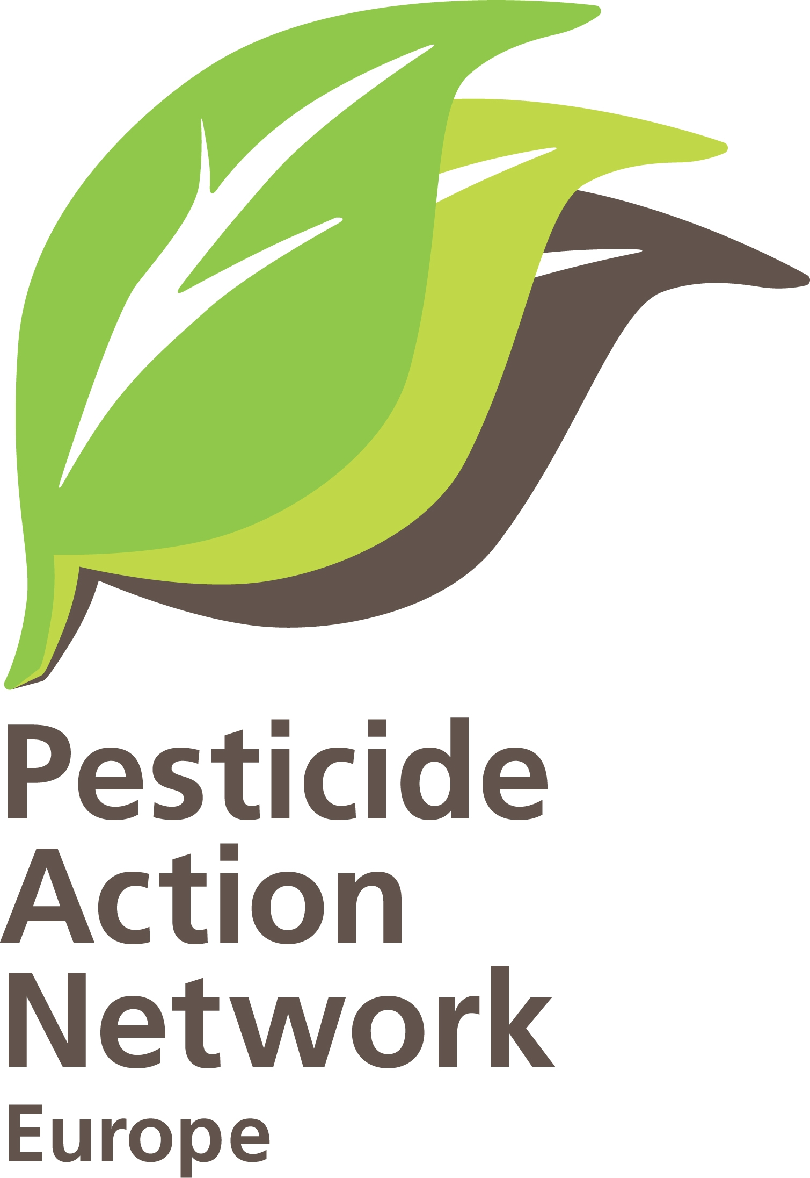 | PAN Europe request for internal review  Brussels, December 21, 2011  Contact: Hans Muilerman, tel. 00316-55807255

Mr. John Dalli
European Commissioner for Health and Consumer Protection
European Commission
B-1049 Brussels
Belgium.
cab-dalli-webpage@ec.europa.eu

Re: Request for an internal review of Commission Implementing Regulation (EU) No 1143/2011 of 10 November 2011

Dear Commissioner, dear Mr. Dalli,

Herewith Pesticide Action Network Europe (PAN Europe) submits a formal request for an internal review (based on Regulation 1367/2006, article 10) of Commission Implementing Regulation 1143/2011 of 10/11/2011 which was published in the Official Journal of 11/11/2010. It is the opinion of our organisation that Commission Implementing Regulation 1143/2011, granting market access to the plant protection product Prochloraz, is not justified on several grounds and should be reviewed as a matter of urgency. Please find below the basis of our request.
Procedural criteria:
Our organisation is entitled to make this request because we fulfil the criteria laid down in article 11 of Regulation 1367/2006. PAN-Europe is an independent non-profit-making legal persons in accordance with the national and European law. Promoting environmental protection is one of our central objectives which we are actively pursuing. We attach our statutes, our last two annual reports and a copy of our tax exemption status in Belgium to this request.
Legal considerations:
In an earlier decision concerning a request for internal review concerning the decision of placing a plant production product on the market you decided that this was an act of general scope. Therefore you decided not to accept the request for internal review (letter of 21/04/2009, SANCO/E3/FA/bp(2009)D/530234).

In the light of the Judgement of the Court of Justice of 18/10/2011, Case C-128/09 (and others), in particular the considerations 49 to 57 we ask you to reconsider your opinion. This judgement makes clear that the Aarhus treaty requires that depending on their content it should be possible to challenge acts of a general scope, even if the are formally to be considered as legislation. The exception of 'acts of general scope' as such, as maintained by the commission, must be considered a violation of the Aarhus convention.

To our opinion the decision to place a plant protection product on the market cannot be considered as having the character of legislation in the sense that the Aarhus treaty requires to make it exempt from review by a court. It is of a highly executive nature (it is in fact the application of general standards to concrete situation) and has a concrete object (an active substance). At least part of the technical assessment (whether the product is at all acceptable) is decided on this level of decision making and as such of a different character from the assessment that is later made by member-states (whether the product is acceptable under specific local substances).

An interpretation of Regulation 1367/2006 in conformity with the Aarhus convention should mean that the decision to place a plant protection product on the market is interpreted according to its substance, which is at least partly not an act of general scope, but an executive decision concerning a very concrete object.

Grounds for internal review:

Directive 91/414, now replaced by Regulation 1107/2009, obliges decisions on approval to be taken "in the light of current scientific and technical knowledge" (art.4). This condition has been in force since 1991 and is not changed now Regulation 1107/2009 replaced the former Directive. Undisputable the large knowledge of academia and the publications of researchers in scientific journals are part of this “current scientific knowledge", if not even the core of current scientific knowledge. Regulators however have been slow in adopting the crucial condition of taking decisions in the light of current knowledge. They many times didn't take independent scientific literature into account and based their decisions solely on industry-sponsored studies. While these industry-sponsored studies are largely based on OECD guidelines they will generally run behind current scientific knowledge for 10 -15 years of even sometimes more. Current scientific knowledge therefore is missed if the decision is based only on these industry studies. Potentially important information on the negative effects for humans or the environment is missed if independent literature is disregarded, resulting in an inadequate protection of citizens.

Politicians tried to end this unwanted situation of disregarding independent science by including a clarifying provision in the 2009-Regulation and obliged regulators to take scientific peer-reviewed open literature into account. This however opens no way for disregarding current scientific knowledge if decisions are still based on Directive 91/414 as will be the case for some time.

In the decision on the pesticide Prochloraz important literature on effects of the chemical on humans and especially the vulnerable is disregarded and appropriate safety tests not conducted. This is not ensuring a high level of protection as the Directive and Regulation require.

Prochloraz is a fungicide approved for use in cereals and mushrooms. Prochloraz has been on the market for decades and the assessment of the possible adverse effects on human and the environment started late, some 15 years after the entering in force of Directive 91/414.
Only in 2007 the Rapporteur Member State Ireland send a draft assessment report (DAR) to food authority EFSA for peer-review. This peer-review procedure was cancelled after the voluntary withdrawal of Prochloraz (2008/934/EC) by the applicant.
The withdrawal appeared to be a cosmetic move of the applicant while a new application was made based on the so-called resubmission regime (33/2008/EC). This remarkable regime allows non-approved chemicals to apply for an approval in a fast-track procedure WHILE allowing the non-approved chemical market access. It is highly questionable if this regime is in agreement with the high level of protection Directive 91/414 requires and the precautionary principle.

Finally the application and possibly new information submitted by applicant resulted in Ireland preparing an additional report (AD) which is submitted to EFSA in 2010. On the basis of this report and consultations with Member States, EFSA published their peer-review opinion in 2011.
The peer-review shows applicants again still didn’t deliver enough information and still numerous ‘data gaps’ were identified (see Annex). The risk assessment for groundwater could not be finalised. Information is lacking for assessing long-term risk for mammals, for assessing endocrine disrupting effects on birds, for assessing risks for earthworm eating mammals, etc. It is even not sure if the batches of Prochloraz of the (animal) safety testing were similar to those asked an application for (highest level of concern in EFSA terminology). All these defects in the dossier should be enough reason for not granting market access to Prochloraz.

For human health EFSA considered the standard obligatory safety tests. Hepatocellular tumours were observed and a safe dose was assumed at a level these tumours might not occur anymore. Toxic effects on reproduction in animals studies were seen but at a higher level than the tumour effects. In the discussion on reproductive toxicity short mentioning is made on studies of Vinggaard/Christensen on sexual malformations but they are disregarded because they were observed at higher levels.

Interestingly on the paragraphs on environment, EFSA all of a sudden states “Prochloraz belongs to the group of imidazole fungicides that are suspected to have potential endocrine disrupting properties”. Why this is not an important element of the risk assessment for humans remains unclear. And subsequently EFSA starts analysing the potential adverse endocrine disrupting properties for birds, mammals and fish. They state that there is no protocol for birds and that available reprotoxic tests do not cover endocrine disruption. The final conclusion on birds is that information is lacking and the assessment cannot be finalised.
For mammals and fish amazingly the opposite conclusion is drawn that reprotoxic studies could cover endocrine disruption (mammals) or are enough “conservative” (fish). It is not mentioned were these assumptions are based upon. If data are lacking there can be no other conclusion than that we are not sure about effects, and Commission should conclude to a non-approval of Prochloraz.

This peer-review makes it perfectly clear that the assessment for endocrine disrupting effects of Prochloraz on humans is not performed at all. While Rapporteur, EFSA and Commission know very well Prochloraz is a known endocrine disruptor, they do not assess the effects. This is the more puzzling since on the contrary for the environment an assessment is made, though not more than an attempt. Given the high protection goal for humans (on the level of individuals, while for the environment on the level of populations) this omission is unacceptable, especially given the well-known effects of Prochloraz as stated by EFSA.

Prochloraz is known for its endocrine disrupting properties, having anti androgenic effects by inhibiting steroid synthesis. However in the DAR and EFSA peer-review these effects are not assessed and the independent science is not taken into account in the final decision.
Studies by independent researchers have developed a large knowledge-base on the endocrine disrupting properties of Prochloraz by carrying out mechanistic studies and in-vivo studies.

Prochloraz appears to function via multiple pathways of disruption resulting in several adverse effects like the feminisation of male offspring and sexual malformations. This happens even at very low doses as can be expected in the case of endocrine disruption and hormones functioning with minute doses. Referring to traditional reprotoxicity safety testing, as EFSA does, makes no sense. This is the more the case since the relevant endpoints for endocrine disruption in traditional narrow-focussed reprotoxicity testing are lacking and you will find no effects.

Prochloraz belongs to the group of chemicals known as conazoles and is even one of the most potent of the group making it the more incomprehensible the endocrine disrupting effects of Prochloraz on humans are dismissed.
Prochloraz and other pesticides of the group of conazoles are widely used in agriculture. This means man is exposed to multiple conazoles at the same time. Conazoles are also used as pharmaceuticals for humans and livestock at a large scale. Possible cumulative and synergistic effects therefore need to be taken into account. In EFSA peer-review nor in the final decision there is a sign of taking these important effects into account.

Scientific peer-reviewed open literature could have easily provided for information to EFSA and the Rapporteur, while it is hard to understand why the Rapporteur didn’t require the applicant in the long negotiation process on resubmission to conduct specific safety tests for endocrine disruption. Especially while the adverse endocrine disrupting effects of Prochloraz were well-known at that time. Standardised tests for endocrine disruption are available, while even testing is underway in the US.
Also no extra safety factor to account for unknown effects of endocrine disruption is considered in the final decision on Prochloraz.

Below we summarise the independent scientific literature on the endocrine disrupting effects of Prochloraz to show part of the information that EFSA and Commission did not consider in “the light of current scientific …...knowledge”.

It is already known for decades Prochloraz is an endocrine disrupting agent and inhibiting aromatase, as shown by the article of Mason et al. from 1987.

Many studies are available where researchers try to elucidate the mechanism of action of Prochloraz. This is important. If you know what routes the disruption follows and what negative effects can be expected, regulators know what to look for. Standard (reprotox) testing many times is useless if the negative effects are not known and you have no idea what to look for.

Blystone et al., 2007 is one of a group of scientists showing malformations in male rat offspring. Steroid biosynthesis is disturbed (progesterone up, testosteron down) at the lowest doses tested, a level of 7,8 mg/kg exposure in rats. The no-effect level, if it exists at all, will be much lower and is very soon close to the “safe level” of EFSA (0,9 g/kg). Low dosed studies on Prochloraz mainly have been performed in other vertebrates like fish and this gives already an indication of effects at low level (0,016 mg/L endocrine effects on sexual development). The need to perform low dose tests in mammals is clear.

For clarification, scientists are not interested generally in finding a level of no concern, they look what is happening at effect level, to elucidate the process. Regulators are very much focussed on no-effect levels. If findings in independent literature show adverse effects at a certain level, it should trigger regulators to force industry to do additional tests, including at low doses. And not simply disregard studies.

Noriega e al., 2005 also performed in-vivo studies showing effects of Prochloraz on pups mortality and sexual malformations in male offspring.

Ohlsson et al., 2009 conducted a mechanistic study in a human cell line and showed a biphasic mode of action of Prochloraz at very low levels. Inhibition of CYP enzymes leads to a lower level of gene expression causing developmental toxicity. Ohlsson suggests possible effects on homeostasis and human health in vivo.
Kjaerstad et al., 2011, using in-vitro test systems for endocrine disruption, showed that Prochloraz is one of the most potent endocrine disrupting chemical among the group of conazoles.
Ghisari et al., 2005 in a rat cell line showed the interference of Prochloraz with thyroid hormones at very low levels (10-8 – 10-5 M) with possible effects on brain development.
Vinggaard et al., 2006 reviewed previous literature on the mode of action of Prochloraz and identified 4 different mode of actions of endocrine disturbance of Prochloraz. Antagonizing androgen, antagonizing estrogen, agonizing AR receptor and inhibition of aromatase. In vivo it is an anti androgen, feminizing male offspring. It is demonstrated to have the extremely dangerous potential of causing irreversible effects in the long term like on behaviour while being exposed with Prochloraz parentally. The effects are not theoretical. Vinggaard mentions a study in which sons of female gardeners (glasshouses) show increased occurrence of these effects.

Vinggaard et al., 2005 conducted in-vivo studies at high levels of Prochloraz and concluded the effect of Prochloraz is similar to that of the pesticide Fenarimol (which is banned by EU Commission). Given the very low toxic dose of Fenarimol for in-utero exposure, a LOEL of 0,002 mg/kg in mouse, effects below the “safe level” of Prochloraz of 0,9 mg/kg are very well possible, also given the general non-monotonic dose-response curves of endocrine disrupting chemicals.
Endocrinologist like those of the "Endocrine Society" acknowledge the non-traditional dose-response curves and the low effect doses, sometimes even at infinitesimally low doses.

Regarding cumulative and synergistic effects of pesticides and chemicals with a similar mode of action several studies are available.
Hass et al., 2011 showed effects of a combination of anti-androgens, among which Prochloraz, to have an effect if they are mixed at or below their ‘apparent’ NOEL for these effects. This means NOEL’s are no real NOEL’s but just the limit of sensitivity of the assays. This same is true many times for the traditional safety tests EFSA is peer-reviewing. Some are notorious insensitive (cancer testing in pesticide data requirements).
In vivo studies in rats showed the same result, Jacobsen at al., 2009
Birkhoj, 2004 performed in-vivo studies in rats and again showed additive effects of similarly working pesticides among which Prochloraz.

In conclusion the decision for approval of Prochloraz is made while important and obligatory information was lacking and made without taking account of current scientific knowledge, especially the well-known effects of endocrine disruption. PAN Europe feels Commission is not providing the high level of protection that is required by Directive 91/414 and puts citizens, especially the vulnerable at unknown, but potentially grave risks. Exposure at the early stages of life with Prochloraz (and similar chemicals) at low doses might result in irreversible harmful effects in later life like brain damage, and to the offspring like feminisation and sexual malformations.

We therefore ask you to review Commission Implementing Regulation (EU) No 1143/2011 of 10 November 2011.

Yours sincerely,
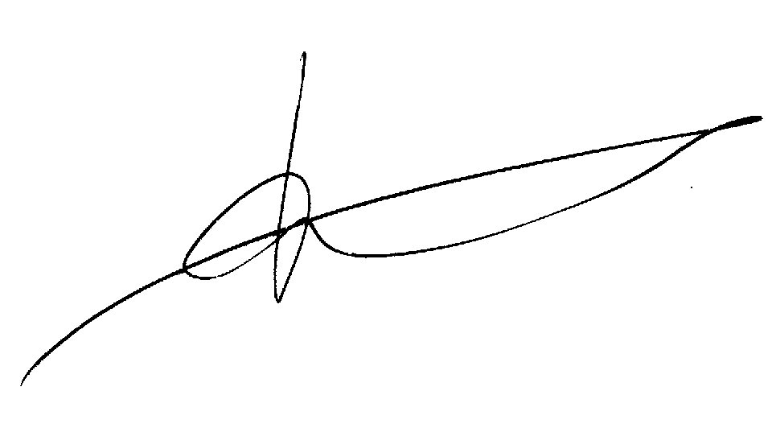

H.Muilerman,
Pesticide Action Network Europe.

Annex.
EFSA conclusion after Resubmission (2011).

7. List of studies to be generated, still ongoing or available but not peer reviewed
This is a complete list of the data gaps identified during the peer review process, including those areas
where a study may have been made available during the peer review process but not considered for
procedural reasons (without prejudice to the provisions of Article 7 of Directive 91/414/EEC
concerning information on potentially harmful effects).
• A revised specification for prochloraz that is supported by the available data (relevant for all
representative uses evaluated; submission date proposed by the applicant: unknown; see section
1).
• 5 batch analysis for the prochloraz copper complex with supporting validated methods of analysis
(relevant for the representative formulation ‘Prelude 20 FS’; submission date proposed by the
applicant: unknown; see section 1).
• The level of ethoxylation of the co-formulants should be clarified (relevant for the representative
formulations ‘Sportak 45 EW’ and ‘Prelude 20 FS’; submission date proposed by the applicant:
unknown; see section 1).
• Fully validated method of analysis for products of animal origin including ILV (relevant for the
representative uses on cereals; submission date proposed by the applicants: unknown; see section
1).
• Method of analysis for BTS 40348 in surface water (relevant for all representative uses evaluated;
submission date proposed by the applicants: unknown; see section 1).
• Once the specification is finalised, sufficient information is required to demonstrate compliance of
the batches tested in the mammalian toxicology and ecotoxicology studies with the final
specification (relevant for all representative uses evaluated; submission date proposed by the
applicants: unknown; see sections 2 and 5).
• An evaluation of the studies addressing the acute toxicity of ‘Mirage 45 EC’, and an assessment of
the non-dietary exposure to prochloraz in ‘Mirage 45 EC’ is not available, see section 2.
• A full residue dataset for cereals, conducted according to the GAPs proposed by Mahkteshim
Agan (540g a.s./ha) and where samples are analysed according to the proposed residue definitions
(relevant for the Makhteshim Agan representative uses on cereals, submission date proposed by
the applicant: unknown; see section 3).
• A storage stability study for the metabolite BTS 44596 in cereal matrices covering the length of
time the samples from the residue trials were stored frozen, and where samples are not analysed
according to a common moiety method (relevant for the representative uses evaluated in cereals,
submission date proposed by the applicants: unknown; see section 3).
• A storage stability study for prochloraz and its metabolites BTS 44595 and BTS 44596 in animal
matrices where samples are not analysed according to a common moiety method (relevant for the
representative uses evaluated in cereals, submission date proposed by the applicants: unknown;
see section 3).
• Further information is considered necessary to conclude on whether results from studies on the
route and rate of degradation in soil and natural surface water systems dosed with prochloraz
might be used alone to assess the fate and behaviour of the variant prochloraz copper complex.
Some studies on the variant might be necessary (relevant for used as a cereal seed treatment;
submission date proposed by the applicant: unknown; see section 4).
Peer Review of the pesticide risk assessment of the active substance prochloraz
EFSA Journal 2011; 9(7):2323 20
• Further information is considered necessary to conclude on whether results from assessed studies
on the route and rate of degradation in soil and natural surface water systems dosed with
prochloraz might be used alone to assess the fate and behaviour of the variant prochloraz zinc
complex. Some studies on the variant might be necessary (relevant for the use in mushrooms; see
section 4).
• Annex III environmental exposure assessments (PEC calculations in soil, surface water, sediment
and groundwater) for the representative uses on cereals with dose rates above 450g/ha and for the
representative use on mushrooms, using the annex II endpoints agreed by the peer review
(contained in Appendix A of the EFSA conclusion) are not available, see section 4.
• Risk assessments for wild non-target species using the annex II endpoints agreed by the peer
review for the representative uses on cereals with dose rates above 450g a.s./ha and for the
representative use on mushrooms are not available, see section 5.
• The risk assessment of the variant zinc complex to non-target species should be addressed
(relevant for the representative use on mushrooms; submission date proposed by the applicant:
unknown; see section 5).
• Further information to address the long-term risk to mammals (relevant for the representative uses
on cereals as a spray at rates up to 450g a.s./ha and as a seed treatment; submission date proposed
by the applicant: unknown; see section 5).
• Further information to address the endocrine disrupting effects on birds (relevant for all
representative uses evaluated; submission date proposed by the applicants: unknown; see section
5).
• Further information to address the risk to earthworm-eating mammals (relevant for the
representative use in cereals as a spray at rates up to 450g a.s./ha; submission date proposed by the
applicant: unknown; see section 5).
8. Particular conditions proposed to be taken into account to manage the risk(s) identified
• The EW formulation is not a stable emulsion in the pesticide container. Therefore labelling the
product with a phrase such as ‘shake well before use’ should be considered.
• Considering the representative use in cereal crops (foliar spray application up to 450 g a.s./ha) the
estimated operator exposure is below the AOEL if personal protective equipment (PPE) is used
during mixing, loading and application (i.e. gloves during mixing and loading and coveralls and
sturdy footwear during application) according to the German Model. Worker exposure is below
the AOEL assuming that workers wear trousers and a long sleeved shirt (see section 2).
• Regarding seed treatment in cereal crops, the estimated operator exposure is below the AOEL with
the use of PPE (coveralls and gloves) according to the Seed Tropex Model (see section 2).
• Operator exposure estimates in mushroom cultivation are below the AOEL if PPE (coveralls and
gloves) is used during mixing, loading and application according to the Dutch Model (see section
2).
• Risk mitigation measures comparable to no-spray buffer zones and vegetated run-off buffer strips
up to 10m are required to identify a low risk for aquatic organisms for 5 out of 9 FOCUS scenarios
(D2, D3, D4, D5,and D6) for the use on cereals as a spray at rates up to 450g a.s./ha. When risk
mitigation is increased to the ceilings recommended by FOCUS (2007) (afforded by 20m no-spray
buffer zones and run-off mitigated by 80% in solution and 95% as eroded soil), all 9 FOCUS
scenarios indicate a low risk (see section 5).
Peer Review of the pesticide risk assessment of the active substance prochloraz
EFSA Journal 2011; 9(7):2323 21
9. Concerns
9.1. Issues that could not be finalised
An issue is listed as an issue that could not be finalised where there is not enough information
available to perform an assessment, even at the lowest tier level, for the representative uses in line
with the Uniform Principles of Annex VI to Directive 91/414/EEC and where the issue is of such
importance that it could, when finalised, become a concern (which would also be listed as a critical
area of concern if it is of relevance to all representative uses).
1. The human non-dietary risk assessment for the representative uses on cereals as a foliar spray at
application rates above 450g a.s./ha, could not be finalised (see section 2).
2. Conclusions on the groundwater exposure potential and other environmental exposure and
consequent environmental risk assessments for the representative uses on mushrooms and cereals
as a foliar spray at application rates above 450g a.s./ha, could not be finalised, since these
assessments were not presented by the RMS.
3. The environmental exposure assessments for prochloraz copper complex and prochloraz zinc
complex could not be finalised. Consequently the groundwater exposure assessment for these two
variants was not finalised. The risk assessment to wild non-target species was not finalised for the
prochloraz zinc complex variant.
4. The assessment of endocrine disrupting effects on birds could not be finalised.
9.2. Critical areas of concern
An issue is listed as a critical area of concern where there is enough information available to perform
an assessment for the representative uses in line with the Uniform Principles of Annex VI to Directive
91/414/EEC, and where this assessment does not permit to conclude that for at least one of the
representative uses it may be expected that a plant protection product containing the active substance
will not have any harmful effect on human or animal health or on groundwater or any unacceptable
influence on the environment.
An issue is also listed as a critical area of concern where the assessment at a higher tier level could not
be finalised due to a lack of information, and where the assessment performed at the lower tier level
does not permit to conclude that for at least one of the representative uses it may be expected that a
plant protection product containing the active substance will not have any harmful effect on human or
animal health or on groundwater or any unacceptable influence on the environment.
5. There was no agreed specification (see section 1), and it was not possible to establish whether the
batches tested in the mammalian toxicology and ecotoxicology studies were in compliance with
the proposed specification by BASF and Makhteshim Agan (see sections 2 and 5).

European Food Safety Authority; Conclusion on the peer review of the pesticide risk assessment of the active substance prochloraz. EFSA Journal 2011; 9(7):2323. [120 pp.]. doi:10.2903/j.efsa.2011.2323. Available online: www.efsa.europa.eu/efsajournal.htm
Statement of Professor Kortenkamp, the expert hired by DG Environment in the "expert meeting" on criteria for endocrine disruption, Brussels, November, 17, 2011, and included in a report commissioned by DG Environment to be published December 2011.
http://www.oecd.org/document/58/0,3746,en_2649_34377_2348794_1_1_1_1,00.html
Mason, J. I., Carr, B. R., and Murry, B. A. (1987). Imidazole antimycotics: selective inhibitors of steroid aromatization and progesterone hydroxylation. Steroids 50, 179–189.
Chad R. Blystone, Christy S. Lambright, Kembra L. Howdeshell, Johnathan Furr, Robin M. Sternberg, Brian C. Butterworth, Elizabeth J. Durhan, Elizabeth A. Makynen, Gerald T. Ankley, Vickie S. Wilson, Gerald A. LeBlanc, and L. Earl Gray Jr, Sensitivity of Fetal Rat Testicular Steroidogenesis to Maternal Prochloraz Exposure and the Underlying Mechanism of Inhibition, TOXICOLOGICAL SCIENCES 97(2), 512–519 (2007)
Kinnberg K , Holbech H , Petersen GI , Bjerregaard P, Effects of the fungicide prochloraz on the sexual development of zebrafish (Danio rerio). Comp Biochem Physiol C Toxicol Pharmacol. 2007 Mar; 145(2):165-70.
Nigel C. Noriega, Joseph Ostby, Christy Lambright, Vickie S. Wilson, and L. Earl Gray, Jr., Late Gestational Exposure to the Fungicide Prochloraz Delays the Onset of Parturition and Causes Reproductive Malformations in Male but Not Female Rat Offspring, BIOLOGY OF REPRODUCTION 72, 1324–1335 (2005)
Åsa Ohlsson, Erik Ullerås, Agneta Oskarsson, A biphasic effect of the fungicide prochloraz on aldosterone, but not cortisol, secretion in human adrenal H295R cells—Underlying mechanisms, Toxicology Letters 191 (2009) 174–180
Mia B. Kjærstad, Camilla Taxvig, Christine Nellemann, Anne Marie Vinggaard, Helle R. Andersen, Endocrine disrupting effects in vitro of conazole antifungals used as pesticides and pharmaceuticals, Reproductive Toxicology 30 (2010) 573–582
Mandana Ghisari, Eva C. Bonefeld-Jorgensen, Impact of environmental chemicals on the thyroid hormone function in pituitary rat GH3 cells, Molecular and Cellular Endocrinology 244 (2005) 31–41
Anne Marie Vinggaard, Ulla Hass, Majken Dalgaard, Helle Raun Andersen, Eva Bonefeld-Jørgensen, Sofie Christiansen, Peter Laier and Mette Erecius Poulsen, Prochloraz: an imidazole fungicide with multiple mechanisms of action, international journal of andrology 29 (2006) 186–192.
Anne Marie Vinggaard, Helene Jacobsen, Stine Broeng Metzdorff, Helle Raun Andersen, Christine Nellemann, Antiandrogenic effects in short-term in vivo studies of the fungicide fenarimol, Toxicology 207 (2005) 21–34
Mira Park, Jiyou Han, Jeong-Jae Ko, Woo-Sik Lee, Tae Ki Yoon, Kangseok Lee, Jeehyeon Bae, Maternal exposure to fenarimol promotes reproductive performance in mouse offspring, Toxicology Letters 205 (2011) 241– 249
Anderson J.M. Andrade, Simone W. Grande, Chris E. Talsness, Konstanze Grote, Ibrahim Chahoud, A dose–response study following in utero and lactational exposure to di-(2-ethylhexyl)-phthalate (DEHP): Non-monotonic dose–response and low dose effects on rat brain aromatase activity, Toxicology 227 (2006) 185–192
Evanthia Diamanti-Kandarakis, Jean-Pierre Bourguignon, Linda C. Giudice, Russ Hauser, Gail S. Prins, Ana M. Soto, R. Thomas Zoeller, and Andrea C. Gore, Endocrine-Disrupting Chemicals: An Endocrine Society Scientific Statement, Endocrine Reviews, June 2009, 30(4):293–342
Pernille Rosenskjold Jacobsen, Sofie Christiansen, Line Harder Clemmensen, Marta Axelstad, Bjarne K. Ersbøll, Ulla Hass, Prediction of gestation length and nipple retention in rats after mixed exposure to low doses of dissimilarly acting endocrine disrupting pesticides, Reproductive Toxicology 32 (2011) 164–179
P. R. Jacobsen, S. Christiansen, J. Boberg, C. Nellemann and U. Hass, Combined exposure to endocrine disrupting pesticides impairs parturition, causes pup mortality and affects sexual differentiation in rats, International Journal of Andrology 33 (2010), 434–442
Mia Birkhøj, Christine Nellemann, Kirsten Jarfelt, Helene Jacobsen, Helle Raun Andersen, Majken Dalgaard, Anne Marie Vinggaard, The combined antiandrogenic effects of five commonly used pesticides, Toxicology and Applied Pharmacology 201 (2004) 10– 20

