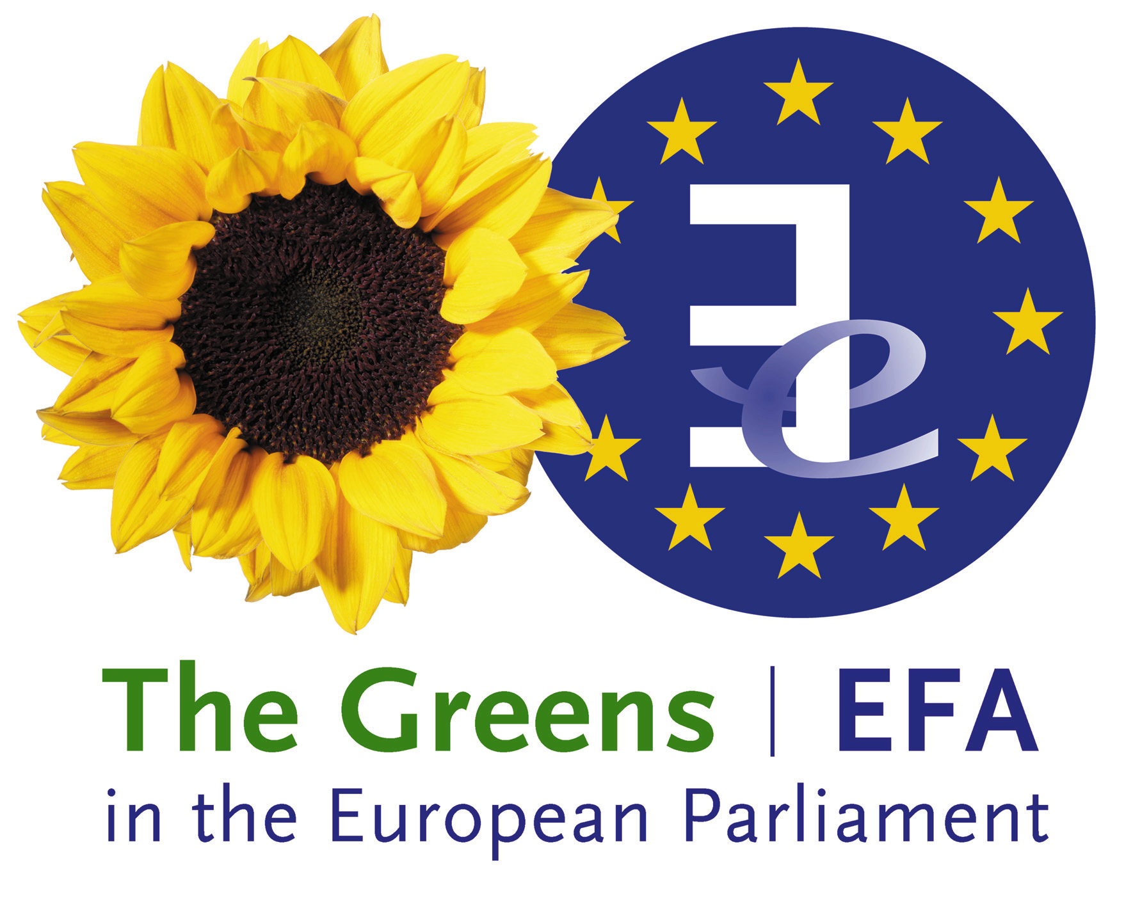 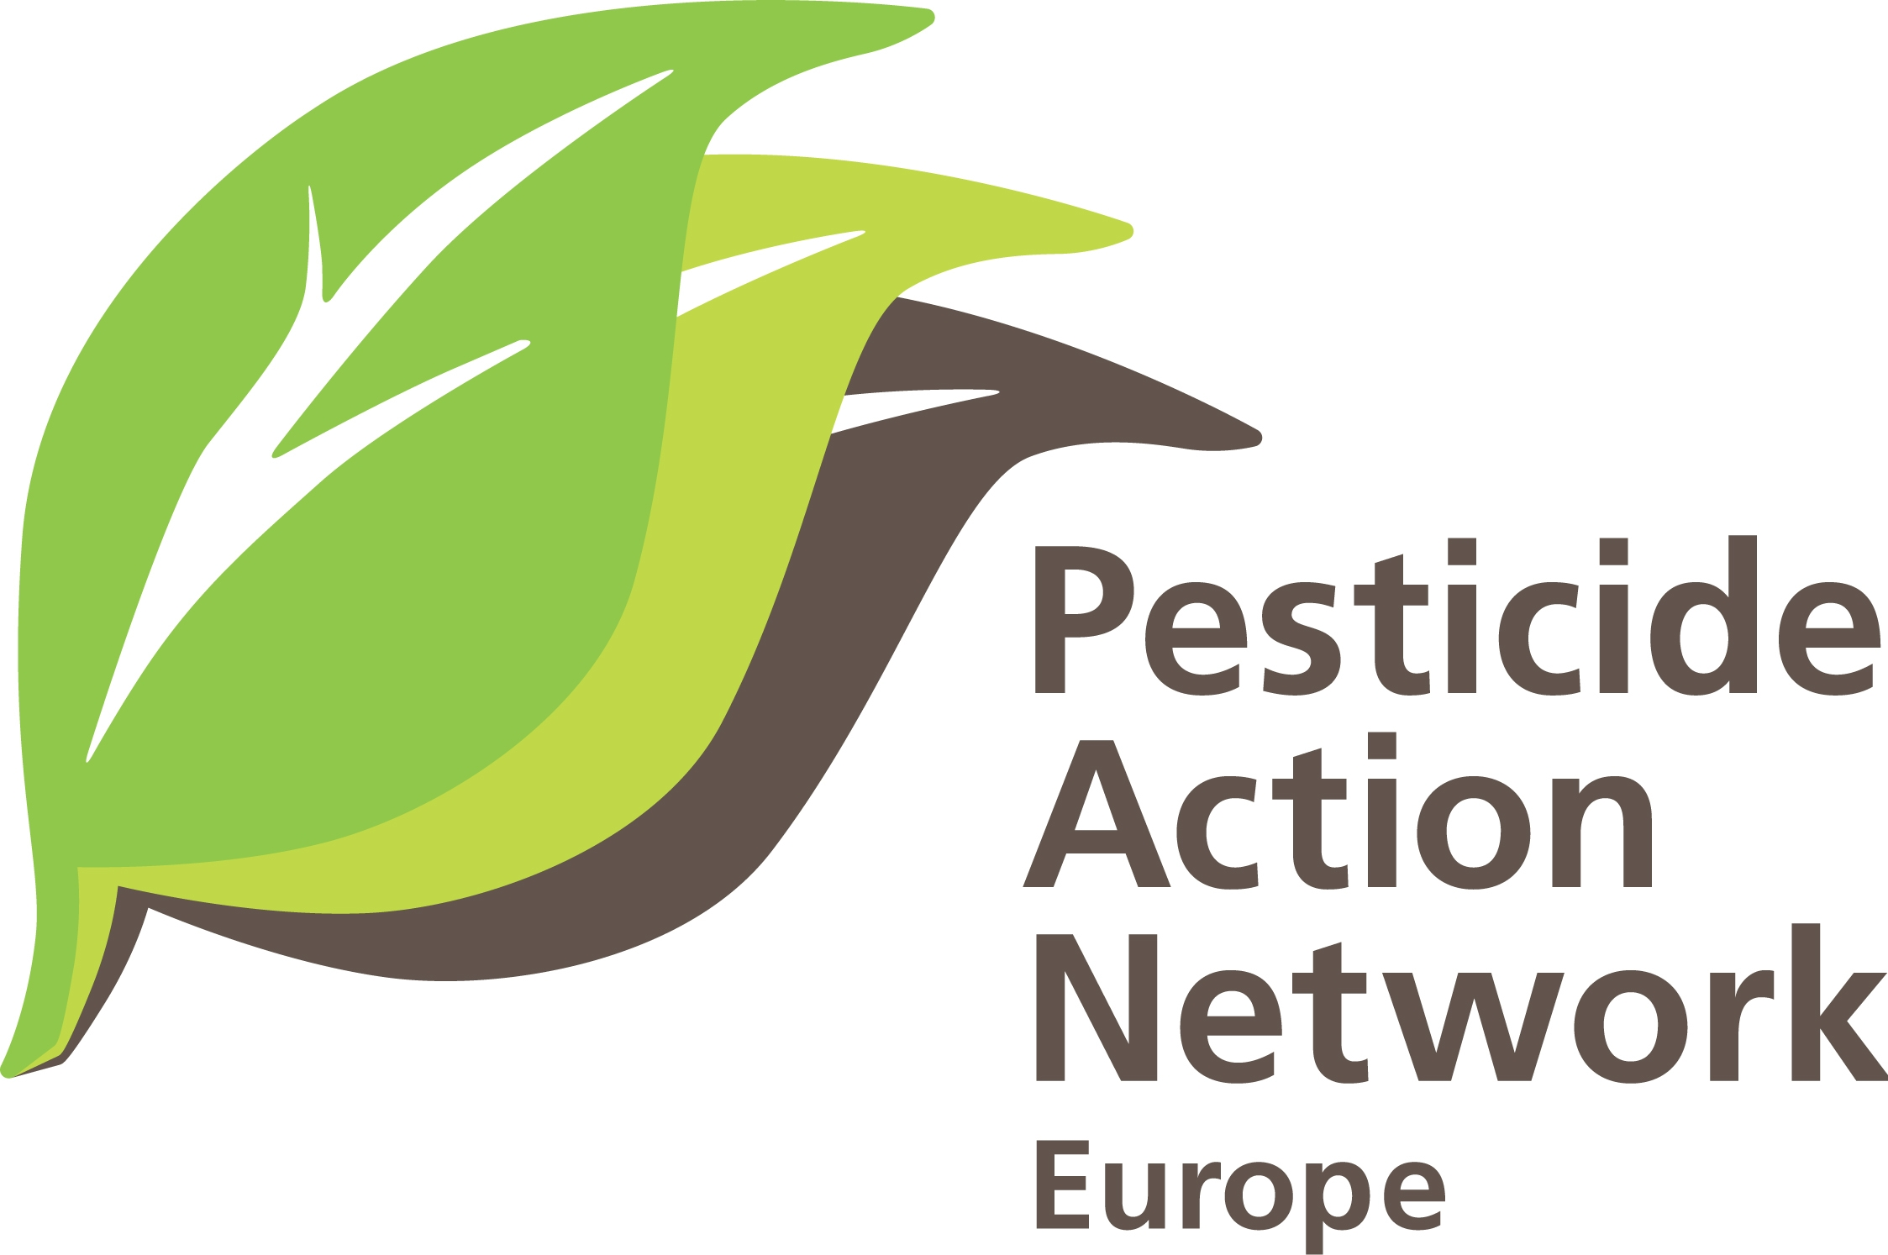
Conference-debate
Pollinator friendly farming is possible
22nd of March 9:00 - 12:00
European Parliament - Room PHS 4B1
The event is co-organised by Bart Staes Greens/EFA MEP, the European Beekeeping Coordination and PAN Europe, in the framework of the Week Without Pesticides.
To register, send by the 20 of March, your name, surname, date of birth, ID number, country to Carolina Cardoso: cardoso@bee-life.eu
Presentation: The aim of the event is to share experience on alternatives to neonicotinoid pesticides with academics, farmers, beekeepers, policy makers, NGOs, citizens…. Scientists and field technicians are going to present their research on alternative agricultural practices to neonicotinoids. Farmers will explain how they manage the implementation of such practices and which challenges they face. Beekeepers are going to explain their challenges and opportunities when interacting with agriculture.
Debated issue: Risks of neonicotinoids for bee health and environmental safety have been acknowledged. Let’s take this as an opportunity to put on the table solutions and to spread pollinator friendly farming models. Let’s discuss on how to recover a synergy between pollinator health and agricultural practices, taking into account economic, environmental and social aspects?
Honey degustation during the conference.
A report of debated topics is going to be sent to participants after the conference.
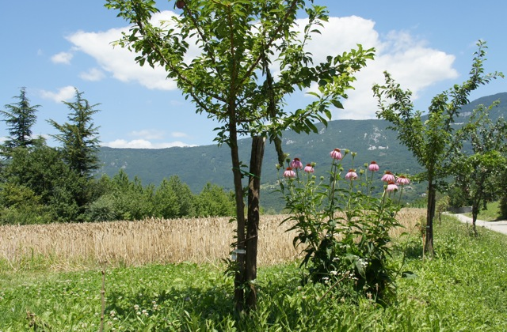
Programme
8.15 - 9.00 |  | Arrival of participants
9.05- 9.15 |  | Keynote Speech - Beekeeping and agriculture: together again!  Chair, Bart Staes, Greens/EFA MEP.
Agroecology: questioning current agricultural systems
9.15 - 9.40 | Dr. Louis Hautier, entomologist and agronomist from the Belgian group of agroecology www.agroecologie.be
Case studies: scientific and field studies - Which agricultural alternatives to neonicotinoids?
9.40 - 10.05  10.05 -10.30  10.30 – 10.55 |  | Dr. Lorenzo Furlan, department of agricultural research at Veneto Agricoltura - Crop rotation systems implemented with farmers - www.venetoagricoltura.org  Dr. Merijn Bos, Researcher in agroecology at the Louis Bolk Instituut - IPM implemented with farmers and beekeepers. - www.bloeiendbedrijf.nl - www.louisbolk.org  www.boerenmetbijen.nl  E-nema, Company for biotechnology and biological control GmbH - how to link research to the field - www.e-nema.com
Testimony: challenges and possibilities for farmers and beekeepers to work together
11.00 - 11.25 |  | Francesco Panella, spokesman for the European Beekeeping Coordination
11.25 – 12.00 |  | Interactive session and conclusions: in order to collect ideas and build solutions for pollinator friendly farming and alternatives to neonicotinoids.  Chair, Bart Staes, Greens/EFA MEP
http://www.semaine-sans-pesticides.fr/events/une-agriculture-respectueuse-des-pollinisateurs-est-possible/
http://www.greens-efa.eu/pollinator-friendly-farming-is-possible-9317.html

